**YMatrix数据库测试报告**

项目名称：深圳航空数据底座备份平台建设项目

测试单位：用友网络科技股份有限公司

数据库版本：YMatrix 企业版 v6.5.0

|  |  |
| --- | --- |
| 文档版本： | V1.0 |
| 报告日期： | 2025 年 9 月 11 日 |
| 报告人： | 叶旭 |

1. **测试结果**
2. **测试环境**

|  |  |  |  |  |  |
| --- | --- | --- | --- | --- | --- |
| 环境类型 | 节点类别 | 节点数 | CPU core | 内存 GB | 磁盘 GB |
| 测试环境 | 主节点 | 1 | 64 | 256 | 20000 |
| 数据节点1 | 1 | 64 | 256 | 20000 |
| 数据节点2 | 1 | 64 | 256 | 20000 |
| 总计 | | 3 | 192 | 768 | 60000 |

1. 服务器为三台物理机；
2. CPU型号为Intel(R) Xeon(R) Gold 5218 CPU @ 2.30GHz；
3. 操作系统版本为CentOS 7；
4. 网络为万兆内网；
5. 数据库版本为YMatrix 数据库企业版v6.5.0。
6. **功能测试**

YMatrix数据库满足深圳航空各项功能要求。

1. **性能测试**

单位：毫秒

|  |  |  |  |  |  |  |  |
| --- | --- | --- | --- | --- | --- | --- | --- |
| 操作 | 场景 | 数据量 | 数据量 | 数据量 | 数据量 | 数据量 | 数据量 |
| 1,218 | 29,454 | 441,370 | 2,731,118 | 10,850,431 | 108,504,310 |
| 单表查询 | 无时间索引 | 8.55 | 15.73 | 43.91 | 88.60 | 213.81 | 1882.13 |
| 有时间索引 | 7.82 | 14.99 | 40.77 | 88.15 | 233.76 | 1758.30 |
| 插入 | 无索引 | 80.33 | 87.69 | 214.70 | 601.46 | 2451.68 | 27407.05 |
| 有索引 | 87.70 | 174.46 | 283.34 | 995.83 | 4113.93 | 45196.61 |
| 千万数据&无索引 | 240.12 | 213.77 | 444.44 | 1669.51 | 8725.34 | 67132.78 |
| 千万数据&有索引 | 168.30 | 203.01 | 473.15 | 1954.98 | 9440.15 | 77851.49 |
| 更新 | 无索引 | 11.47 | 18.39 | 63.55 | 212.41 | 642.31 | 5445.58 |
| 有索引 | 15.44 | 16.73 | 18.94 | 54.31 | 95.34 | 140.66 |
| 删除 | 无索引 | 40.90 | 43.31 | 59.81 | 82.13 | 166.16 | 607.93 |
| 有索引 | 5.52 | 13.50 | 16.49 | 75.19 | 137.91 | 540.05 |
| 复杂查询 | 无索引 | 617.21 | | | | | |
| 有索引 | 629.08 | | | | | |
| 无索引 | 3083.51 | | | | | |
| 有索引 | 2912.23 | | | | | |

1. 建表默认采用自研mas3引擎并压缩；
2. **测试背景**

针对深圳航空数据底座备份平台建设项目需求，用友提供高性能、易扩展、支持多场景的 YMatrix 企业版超融合数据库，并完成相应测试验证。

1. **测试范围**

本次测试分为功能和性能两部分。功能测试覆盖数据操作、多模存储、流批计算、扩展性、表锁查询及审计等能力；性能测试则验证深圳航空 POC 要求的不同数据量下（万级至亿级）、带索引与否的单表查询、批量增删改操作，以及复杂查询的资源消耗情况。具体要求如下：

|  |  |  |
| --- | --- | --- |
| 数据分析-数据湖 | 数据操作 | 可进行数据的增删改查，支持以事务的形式进行增删改。 |
| 数据存储 | 支持结构化、非结构化数据（图片、文档）的读写、存储、管理。 |
| 数据计算 | 可进行数据的流处理与批处理。 |
| 拓展能力 | 可拓展接入资源对结构化与非结构化数据进行加工处理。 |
| 数据分析-数据仓 | 单表查询 | 查询单表，时间筛选，表有亿级/百万级/万级/万级以下条记录的时间 |
| 查询单表，时间筛选，时间索引，表有亿级/百万级/万级/万级以下条记录的时间 |
| 插入 | 插入亿级/百万级/万级/万级以下条记录的时间，无索引（字段为适量相同数量） |
| 插入亿级/百万级/万级/万级以下条记录的时间，有索引 |
| 修改 | 修改亿级/百万级/万级/万级以下条记录的时间，无索引情况； |
| 修改亿级/百万级/万级/万级以下条记录的时间，有索引情况 |
| 删除 | 删除亿级/百万级/万级/万级以下条记录的时间 |
| 资源消耗 | 复杂查询的资源消耗、最大并发数、最大连接数 |
| 字段类型 | 是否有数值类型（整数、小数），字符串类型，时间类型，布尔类型，二进制数据 |
| 复杂查询 | 复杂语句查询,多表关联、窗口函数、子查询、聚合函数、条件过滤 |
| 加解密 | 对接炼石加解密（提供对接方案） |
| 表锁 | 能查看表锁情况 |
| 审计 | 某时间段表被各用户查询访问的次数 |
| 某时间段某用户执行了哪些SQL |
| 错误语句以及返回的错误信息 |
| 用户会话占用连接的时间和数量 |

1. **测试目标**

验证YMatrix在所给负载下的性能表现；验证YMatrix能够满足所给功能要求。

1. **功能测试**
2. **数据操作——sql语句及其执行结果截图**
3. **数据存储——上传非结构化数据并成功截图**
4. **数据计算——流表建立并运行截图**
5. **拓展能力——分布式架构，mxui页面截图**
6. **字段类型——建表使用相应字段成功截图**
7. **加解密——插件方案**
8. **表锁——平台功能**
9. **数据库审计——插件实现**
10. **性能测试数据准备**
11. **基表数据准备**

|  |
| --- |
| create table ZDX_TEMP_FLYINFO_BASE (  flightno VARCHAR(50),  flightdate date,  flightdepcode VARCHAR(50),  flightarrcode VARCHAR(50),  flightdeptimeplandate timestamp,  flightarrtimeplandate timestamp,  veryzhunreadydeptimedate timestamp,  veryzhunreadyarrtimedate timestamp,  flightdeptimedate timestamp,  flightarrtimedate timestamp,  checkintable VARCHAR(50),  reachexit VARCHAR(50),  baggageid VARCHAR(50),  flightstate VARCHAR(50),  flighthterminal VARCHAR(50),  flightterminal VARCHAR(50),  org_timezone VARCHAR(50),  dst_timezone VARCHAR(50),  stopflag VARCHAR(50),  shareflag VARCHAR(50),  boardgatetime VARCHAR(50),  todaytimerate VARCHAR(50),  delayreason VARCHAR(500),  flightdep VARCHAR(50),  flightarr VARCHAR(50),  bridge VARCHAR(50),  arr_bridge VARCHAR(50),  flightdepairport VARCHAR(50),  flightarrairport VARCHAR(50),  generic VARCHAR(50),  flightyear VARCHAR(50),  flightduration VARCHAR(50),  distance VARCHAR(50),  arrstandgate VARCHAR(50),  depstandgate VARCHAR(50),  aircraft_number VARCHAR(50) )USING MARS3 DISTRIBUTED BY (flightno);  copy zdx_temp_flyinfo_base from '/data/shenhang/2019.csv' with csv header; |

1. **写入主表**

|  |
| --- |
| create table ZDX_TEMP_FLYINFO (  id SERIAL,  flightno VARCHAR(50),  flightdate date,  flightdepcode VARCHAR(50),  flightarrcode VARCHAR(50),  flightdeptimeplandate timestamp,  flightarrtimeplandate timestamp,  veryzhunreadydeptimedate timestamp,  veryzhunreadyarrtimedate timestamp,  flightdeptimedate timestamp,  flightarrtimedate timestamp,  checkintable VARCHAR(50),  reachexit VARCHAR(50),  baggageid VARCHAR(50),  flightstate VARCHAR(50),  flighthterminal VARCHAR(50),  flightterminal VARCHAR(50),  org_timezone VARCHAR(50),  dst_timezone VARCHAR(50),  stopflag VARCHAR(50),  shareflag VARCHAR(50),  boardgatetime VARCHAR(50),  todaytimerate VARCHAR(50),  delayreason VARCHAR(500),  flightdep VARCHAR(50),  flightarr VARCHAR(50),  bridge VARCHAR(50),  arr_bridge VARCHAR(50),  flightdepairport VARCHAR(50),  flightarrairport VARCHAR(50),  generic VARCHAR(50),  flightyear VARCHAR(50),  flightduration VARCHAR(50),  distance VARCHAR(50),  arrstandgate VARCHAR(50),  depstandgate VARCHAR(50),  aircraft_number VARCHAR(50),  primary key(id,flightdate) )USING MARS3 WITH(mars3options='prefer_load_mode=single',compresstype=zstd, compresslevel=1) DISTRIBUTED BY (id) ORDER BY (flightdepcode, flightarrcode, flightdate) PARTITION BY RANGE(flightdate)( START('2019-01-01') INCLUSIVE END('2029-12-31') EXCLUSIVE EVERY(INTERVAL '3 month'), DEFAULT PARTITION OTHERS );  insert into ZDX_TEMP_FLYINFO(FLIGHTNO,FLIGHTDATE,FLIGHTDEPCODE,FLIGHTARRCODE,FLIGHTDEPTIMEPLANDATE,FLIGHTARRTIMEPLANDATE,VERYZHUNREADYDEPTIMEDATE,VERYZHUNREADYARRTIMEDATE,FLIGHTDEPTIMEDATE,FLIGHTARRTIMEDATE,CHECKINTABLE,REACHEXIT,BAGGAGEID,FLIGHTSTATE,FLIGHTHTERMINAL,FLIGHTTERMINAL,ORG_TIMEZONE,DST_TIMEZONE,STOPFLAG,SHAREFLAG,BOARDGATETIME,TODAYTIMERATE,DELAYREASON,FLIGHTDEP,FLIGHTARR,BRIDGE,ARR_BRIDGE,FLIGHTDEPAIRPORT,FLIGHTARRAIRPORT,GENERIC,FLIGHTYEAR,FLIGHTDURATION,DISTANCE,ARRSTANDGATE,DEPSTANDGATE,AIRCRAFT_NUMBER) select FLIGHTNO,FLIGHTDATE,FLIGHTDEPCODE,FLIGHTARRCODE,FLIGHTDEPTIMEPLANDATE,FLIGHTARRTIMEPLANDATE,VERYZHUNREADYDEPTIMEDATE,VERYZHUNREADYARRTIMEDATE,FLIGHTDEPTIMEDATE,FLIGHTARRTIMEDATE,CHECKINTABLE,REACHEXIT,BAGGAGEID,FLIGHTSTATE,FLIGHTHTERMINAL,FLIGHTTERMINAL,ORG_TIMEZONE,DST_TIMEZONE,STOPFLAG,SHAREFLAG,BOARDGATETIME,TODAYTIMERATE,DELAYREASON,FLIGHTDEP,FLIGHTARR,BRIDGE,ARR_BRIDGE,FLIGHTDEPAIRPORT,FLIGHTARRAIRPORT,GENERIC,FLIGHTYEAR,FLIGHTDURATION,DISTANCE,ARRSTANDGATE,DEPSTANDGATE,AIRCRAFT_NUMBER from ZDX_TEMP_FLYINFO_BASE;  insert into ZDX_TEMP_FLYINFO(FLIGHTNO,FLIGHTDATE,FLIGHTDEPCODE,FLIGHTARRCODE,FLIGHTDEPTIMEPLANDATE,FLIGHTARRTIMEPLANDATE,VERYZHUNREADYDEPTIMEDATE,VERYZHUNREADYARRTIMEDATE,FLIGHTDEPTIMEDATE,FLIGHTARRTIMEDATE,CHECKINTABLE,REACHEXIT,BAGGAGEID,FLIGHTSTATE,FLIGHTHTERMINAL,FLIGHTTERMINAL,ORG_TIMEZONE,DST_TIMEZONE,STOPFLAG,SHAREFLAG,BOARDGATETIME,TODAYTIMERATE,DELAYREASON,FLIGHTDEP,FLIGHTARR,BRIDGE,ARR_BRIDGE,FLIGHTDEPAIRPORT,FLIGHTARRAIRPORT,GENERIC,FLIGHTYEAR,FLIGHTDURATION,DISTANCE,ARRSTANDGATE,DEPSTANDGATE,AIRCRAFT_NUMBER) select FLIGHTNO,(FLIGHTDATE + INTERVAL '1 YEAR'),FLIGHTDEPCODE,FLIGHTARRCODE,FLIGHTDEPTIMEPLANDATE,FLIGHTARRTIMEPLANDATE,VERYZHUNREADYDEPTIMEDATE,VERYZHUNREADYARRTIMEDATE,FLIGHTDEPTIMEDATE,FLIGHTARRTIMEDATE,CHECKINTABLE,REACHEXIT,BAGGAGEID,FLIGHTSTATE,FLIGHTHTERMINAL,FLIGHTTERMINAL,ORG_TIMEZONE,DST_TIMEZONE,STOPFLAG,SHAREFLAG,BOARDGATETIME,TODAYTIMERATE,DELAYREASON,FLIGHTDEP,FLIGHTARR,BRIDGE,ARR_BRIDGE,FLIGHTDEPAIRPORT,FLIGHTARRAIRPORT,GENERIC,FLIGHTYEAR,FLIGHTDURATION,DISTANCE,ARRSTANDGATE,DEPSTANDGATE,AIRCRAFT_NUMBER from ZDX_TEMP_FLYINFO_BASE;  insert into ZDX_TEMP_FLYINFO(FLIGHTNO,FLIGHTDATE,FLIGHTDEPCODE,FLIGHTARRCODE,FLIGHTDEPTIMEPLANDATE,FLIGHTARRTIMEPLANDATE,VERYZHUNREADYDEPTIMEDATE,VERYZHUNREADYARRTIMEDATE,FLIGHTDEPTIMEDATE,FLIGHTARRTIMEDATE,CHECKINTABLE,REACHEXIT,BAGGAGEID,FLIGHTSTATE,FLIGHTHTERMINAL,FLIGHTTERMINAL,ORG_TIMEZONE,DST_TIMEZONE,STOPFLAG,SHAREFLAG,BOARDGATETIME,TODAYTIMERATE,DELAYREASON,FLIGHTDEP,FLIGHTARR,BRIDGE,ARR_BRIDGE,FLIGHTDEPAIRPORT,FLIGHTARRAIRPORT,GENERIC,FLIGHTYEAR,FLIGHTDURATION,DISTANCE,ARRSTANDGATE,DEPSTANDGATE,AIRCRAFT_NUMBER) select FLIGHTNO,(FLIGHTDATE + INTERVAL '2 YEAR'),FLIGHTDEPCODE,FLIGHTARRCODE,FLIGHTDEPTIMEPLANDATE,FLIGHTARRTIMEPLANDATE,VERYZHUNREADYDEPTIMEDATE,VERYZHUNREADYARRTIMEDATE,FLIGHTDEPTIMEDATE,FLIGHTARRTIMEDATE,CHECKINTABLE,REACHEXIT,BAGGAGEID,FLIGHTSTATE,FLIGHTHTERMINAL,FLIGHTTERMINAL,ORG_TIMEZONE,DST_TIMEZONE,STOPFLAG,SHAREFLAG,BOARDGATETIME,TODAYTIMERATE,DELAYREASON,FLIGHTDEP,FLIGHTARR,BRIDGE,ARR_BRIDGE,FLIGHTDEPAIRPORT,FLIGHTARRAIRPORT,GENERIC,FLIGHTYEAR,FLIGHTDURATION,DISTANCE,ARRSTANDGATE,DEPSTANDGATE,AIRCRAFT_NUMBER from ZDX_TEMP_FLYINFO_BASE;  insert into ZDX_TEMP_FLYINFO(FLIGHTNO,FLIGHTDATE,FLIGHTDEPCODE,FLIGHTARRCODE,FLIGHTDEPTIMEPLANDATE,FLIGHTARRTIMEPLANDATE,VERYZHUNREADYDEPTIMEDATE,VERYZHUNREADYARRTIMEDATE,FLIGHTDEPTIMEDATE,FLIGHTARRTIMEDATE,CHECKINTABLE,REACHEXIT,BAGGAGEID,FLIGHTSTATE,FLIGHTHTERMINAL,FLIGHTTERMINAL,ORG_TIMEZONE,DST_TIMEZONE,STOPFLAG,SHAREFLAG,BOARDGATETIME,TODAYTIMERATE,DELAYREASON,FLIGHTDEP,FLIGHTARR,BRIDGE,ARR_BRIDGE,FLIGHTDEPAIRPORT,FLIGHTARRAIRPORT,GENERIC,FLIGHTYEAR,FLIGHTDURATION,DISTANCE,ARRSTANDGATE,DEPSTANDGATE,AIRCRAFT_NUMBER) select FLIGHTNO,(FLIGHTDATE + INTERVAL '3 YEAR'),FLIGHTDEPCODE,FLIGHTARRCODE,FLIGHTDEPTIMEPLANDATE,FLIGHTARRTIMEPLANDATE,VERYZHUNREADYDEPTIMEDATE,VERYZHUNREADYARRTIMEDATE,FLIGHTDEPTIMEDATE,FLIGHTARRTIMEDATE,CHECKINTABLE,REACHEXIT,BAGGAGEID,FLIGHTSTATE,FLIGHTHTERMINAL,FLIGHTTERMINAL,ORG_TIMEZONE,DST_TIMEZONE,STOPFLAG,SHAREFLAG,BOARDGATETIME,TODAYTIMERATE,DELAYREASON,FLIGHTDEP,FLIGHTARR,BRIDGE,ARR_BRIDGE,FLIGHTDEPAIRPORT,FLIGHTARRAIRPORT,GENERIC,FLIGHTYEAR,FLIGHTDURATION,DISTANCE,ARRSTANDGATE,DEPSTANDGATE,AIRCRAFT_NUMBER from ZDX_TEMP_FLYINFO_BASE;  insert into ZDX_TEMP_FLYINFO(FLIGHTNO,FLIGHTDATE,FLIGHTDEPCODE,FLIGHTARRCODE,FLIGHTDEPTIMEPLANDATE,FLIGHTARRTIMEPLANDATE,VERYZHUNREADYDEPTIMEDATE,VERYZHUNREADYARRTIMEDATE,FLIGHTDEPTIMEDATE,FLIGHTARRTIMEDATE,CHECKINTABLE,REACHEXIT,BAGGAGEID,FLIGHTSTATE,FLIGHTHTERMINAL,FLIGHTTERMINAL,ORG_TIMEZONE,DST_TIMEZONE,STOPFLAG,SHAREFLAG,BOARDGATETIME,TODAYTIMERATE,DELAYREASON,FLIGHTDEP,FLIGHTARR,BRIDGE,ARR_BRIDGE,FLIGHTDEPAIRPORT,FLIGHTARRAIRPORT,GENERIC,FLIGHTYEAR,FLIGHTDURATION,DISTANCE,ARRSTANDGATE,DEPSTANDGATE,AIRCRAFT_NUMBER) select FLIGHTNO,(FLIGHTDATE + INTERVAL '4 YEAR'),FLIGHTDEPCODE,FLIGHTARRCODE,FLIGHTDEPTIMEPLANDATE,FLIGHTARRTIMEPLANDATE,VERYZHUNREADYDEPTIMEDATE,VERYZHUNREADYARRTIMEDATE,FLIGHTDEPTIMEDATE,FLIGHTARRTIMEDATE,CHECKINTABLE,REACHEXIT,BAGGAGEID,FLIGHTSTATE,FLIGHTHTERMINAL,FLIGHTTERMINAL,ORG_TIMEZONE,DST_TIMEZONE,STOPFLAG,SHAREFLAG,BOARDGATETIME,TODAYTIMERATE,DELAYREASON,FLIGHTDEP,FLIGHTARR,BRIDGE,ARR_BRIDGE,FLIGHTDEPAIRPORT,FLIGHTARRAIRPORT,GENERIC,FLIGHTYEAR,FLIGHTDURATION,DISTANCE,ARRSTANDGATE,DEPSTANDGATE,AIRCRAFT_NUMBER from ZDX_TEMP_FLYINFO_BASE;  insert into ZDX_TEMP_FLYINFO(FLIGHTNO,FLIGHTDATE,FLIGHTDEPCODE,FLIGHTARRCODE,FLIGHTDEPTIMEPLANDATE,FLIGHTARRTIMEPLANDATE,VERYZHUNREADYDEPTIMEDATE,VERYZHUNREADYARRTIMEDATE,FLIGHTDEPTIMEDATE,FLIGHTARRTIMEDATE,CHECKINTABLE,REACHEXIT,BAGGAGEID,FLIGHTSTATE,FLIGHTHTERMINAL,FLIGHTTERMINAL,ORG_TIMEZONE,DST_TIMEZONE,STOPFLAG,SHAREFLAG,BOARDGATETIME,TODAYTIMERATE,DELAYREASON,FLIGHTDEP,FLIGHTARR,BRIDGE,ARR_BRIDGE,FLIGHTDEPAIRPORT,FLIGHTARRAIRPORT,GENERIC,FLIGHTYEAR,FLIGHTDURATION,DISTANCE,ARRSTANDGATE,DEPSTANDGATE,AIRCRAFT_NUMBER) select FLIGHTNO,(FLIGHTDATE + INTERVAL '5 YEAR'),FLIGHTDEPCODE,FLIGHTARRCODE,FLIGHTDEPTIMEPLANDATE,FLIGHTARRTIMEPLANDATE,VERYZHUNREADYDEPTIMEDATE,VERYZHUNREADYARRTIMEDATE,FLIGHTDEPTIMEDATE,FLIGHTARRTIMEDATE,CHECKINTABLE,REACHEXIT,BAGGAGEID,FLIGHTSTATE,FLIGHTHTERMINAL,FLIGHTTERMINAL,ORG_TIMEZONE,DST_TIMEZONE,STOPFLAG,SHAREFLAG,BOARDGATETIME,TODAYTIMERATE,DELAYREASON,FLIGHTDEP,FLIGHTARR,BRIDGE,ARR_BRIDGE,FLIGHTDEPAIRPORT,FLIGHTARRAIRPORT,GENERIC,FLIGHTYEAR,FLIGHTDURATION,DISTANCE,ARRSTANDGATE,DEPSTANDGATE,AIRCRAFT_NUMBER from ZDX_TEMP_FLYINFO_BASE;  insert into ZDX_TEMP_FLYINFO(FLIGHTNO,FLIGHTDATE,FLIGHTDEPCODE,FLIGHTARRCODE,FLIGHTDEPTIMEPLANDATE,FLIGHTARRTIMEPLANDATE,VERYZHUNREADYDEPTIMEDATE,VERYZHUNREADYARRTIMEDATE,FLIGHTDEPTIMEDATE,FLIGHTARRTIMEDATE,CHECKINTABLE,REACHEXIT,BAGGAGEID,FLIGHTSTATE,FLIGHTHTERMINAL,FLIGHTTERMINAL,ORG_TIMEZONE,DST_TIMEZONE,STOPFLAG,SHAREFLAG,BOARDGATETIME,TODAYTIMERATE,DELAYREASON,FLIGHTDEP,FLIGHTARR,BRIDGE,ARR_BRIDGE,FLIGHTDEPAIRPORT,FLIGHTARRAIRPORT,GENERIC,FLIGHTYEAR,FLIGHTDURATION,DISTANCE,ARRSTANDGATE,DEPSTANDGATE,AIRCRAFT_NUMBER) select FLIGHTNO,(FLIGHTDATE + INTERVAL '6 YEAR'),FLIGHTDEPCODE,FLIGHTARRCODE,FLIGHTDEPTIMEPLANDATE,FLIGHTARRTIMEPLANDATE,VERYZHUNREADYDEPTIMEDATE,VERYZHUNREADYARRTIMEDATE,FLIGHTDEPTIMEDATE,FLIGHTARRTIMEDATE,CHECKINTABLE,REACHEXIT,BAGGAGEID,FLIGHTSTATE,FLIGHTHTERMINAL,FLIGHTTERMINAL,ORG_TIMEZONE,DST_TIMEZONE,STOPFLAG,SHAREFLAG,BOARDGATETIME,TODAYTIMERATE,DELAYREASON,FLIGHTDEP,FLIGHTARR,BRIDGE,ARR_BRIDGE,FLIGHTDEPAIRPORT,FLIGHTARRAIRPORT,GENERIC,FLIGHTYEAR,FLIGHTDURATION,DISTANCE,ARRSTANDGATE,DEPSTANDGATE,AIRCRAFT_NUMBER from ZDX_TEMP_FLYINFO_BASE;  insert into ZDX_TEMP_FLYINFO(FLIGHTNO,FLIGHTDATE,FLIGHTDEPCODE,FLIGHTARRCODE,FLIGHTDEPTIMEPLANDATE,FLIGHTARRTIMEPLANDATE,VERYZHUNREADYDEPTIMEDATE,VERYZHUNREADYARRTIMEDATE,FLIGHTDEPTIMEDATE,FLIGHTARRTIMEDATE,CHECKINTABLE,REACHEXIT,BAGGAGEID,FLIGHTSTATE,FLIGHTHTERMINAL,FLIGHTTERMINAL,ORG_TIMEZONE,DST_TIMEZONE,STOPFLAG,SHAREFLAG,BOARDGATETIME,TODAYTIMERATE,DELAYREASON,FLIGHTDEP,FLIGHTARR,BRIDGE,ARR_BRIDGE,FLIGHTDEPAIRPORT,FLIGHTARRAIRPORT,GENERIC,FLIGHTYEAR,FLIGHTDURATION,DISTANCE,ARRSTANDGATE,DEPSTANDGATE,AIRCRAFT_NUMBER) select FLIGHTNO,(FLIGHTDATE + INTERVAL '7 YEAR'),FLIGHTDEPCODE,FLIGHTARRCODE,FLIGHTDEPTIMEPLANDATE,FLIGHTARRTIMEPLANDATE,VERYZHUNREADYDEPTIMEDATE,VERYZHUNREADYARRTIMEDATE,FLIGHTDEPTIMEDATE,FLIGHTARRTIMEDATE,CHECKINTABLE,REACHEXIT,BAGGAGEID,FLIGHTSTATE,FLIGHTHTERMINAL,FLIGHTTERMINAL,ORG_TIMEZONE,DST_TIMEZONE,STOPFLAG,SHAREFLAG,BOARDGATETIME,TODAYTIMERATE,DELAYREASON,FLIGHTDEP,FLIGHTARR,BRIDGE,ARR_BRIDGE,FLIGHTDEPAIRPORT,FLIGHTARRAIRPORT,GENERIC,FLIGHTYEAR,FLIGHTDURATION,DISTANCE,ARRSTANDGATE,DEPSTANDGATE,AIRCRAFT_NUMBER from ZDX_TEMP_FLYINFO_BASE;  insert into ZDX_TEMP_FLYINFO(FLIGHTNO,FLIGHTDATE,FLIGHTDEPCODE,FLIGHTARRCODE,FLIGHTDEPTIMEPLANDATE,FLIGHTARRTIMEPLANDATE,VERYZHUNREADYDEPTIMEDATE,VERYZHUNREADYARRTIMEDATE,FLIGHTDEPTIMEDATE,FLIGHTARRTIMEDATE,CHECKINTABLE,REACHEXIT,BAGGAGEID,FLIGHTSTATE,FLIGHTHTERMINAL,FLIGHTTERMINAL,ORG_TIMEZONE,DST_TIMEZONE,STOPFLAG,SHAREFLAG,BOARDGATETIME,TODAYTIMERATE,DELAYREASON,FLIGHTDEP,FLIGHTARR,BRIDGE,ARR_BRIDGE,FLIGHTDEPAIRPORT,FLIGHTARRAIRPORT,GENERIC,FLIGHTYEAR,FLIGHTDURATION,DISTANCE,ARRSTANDGATE,DEPSTANDGATE,AIRCRAFT_NUMBER) select FLIGHTNO,(FLIGHTDATE + INTERVAL '8 YEAR'),FLIGHTDEPCODE,FLIGHTARRCODE,FLIGHTDEPTIMEPLANDATE,FLIGHTARRTIMEPLANDATE,VERYZHUNREADYDEPTIMEDATE,VERYZHUNREADYARRTIMEDATE,FLIGHTDEPTIMEDATE,FLIGHTARRTIMEDATE,CHECKINTABLE,REACHEXIT,BAGGAGEID,FLIGHTSTATE,FLIGHTHTERMINAL,FLIGHTTERMINAL,ORG_TIMEZONE,DST_TIMEZONE,STOPFLAG,SHAREFLAG,BOARDGATETIME,TODAYTIMERATE,DELAYREASON,FLIGHTDEP,FLIGHTARR,BRIDGE,ARR_BRIDGE,FLIGHTDEPAIRPORT,FLIGHTARRAIRPORT,GENERIC,FLIGHTYEAR,FLIGHTDURATION,DISTANCE,ARRSTANDGATE,DEPSTANDGATE,AIRCRAFT_NUMBER from ZDX_TEMP_FLYINFO_BASE;  insert into ZDX_TEMP_FLYINFO(FLIGHTNO,FLIGHTDATE,FLIGHTDEPCODE,FLIGHTARRCODE,FLIGHTDEPTIMEPLANDATE,FLIGHTARRTIMEPLANDATE,VERYZHUNREADYDEPTIMEDATE,VERYZHUNREADYARRTIMEDATE,FLIGHTDEPTIMEDATE,FLIGHTARRTIMEDATE,CHECKINTABLE,REACHEXIT,BAGGAGEID,FLIGHTSTATE,FLIGHTHTERMINAL,FLIGHTTERMINAL,ORG_TIMEZONE,DST_TIMEZONE,STOPFLAG,SHAREFLAG,BOARDGATETIME,TODAYTIMERATE,DELAYREASON,FLIGHTDEP,FLIGHTARR,BRIDGE,ARR_BRIDGE,FLIGHTDEPAIRPORT,FLIGHTARRAIRPORT,GENERIC,FLIGHTYEAR,FLIGHTDURATION,DISTANCE,ARRSTANDGATE,DEPSTANDGATE,AIRCRAFT_NUMBER) select FLIGHTNO,(FLIGHTDATE + INTERVAL '9 YEAR'),FLIGHTDEPCODE,FLIGHTARRCODE,FLIGHTDEPTIMEPLANDATE,FLIGHTARRTIMEPLANDATE,VERYZHUNREADYDEPTIMEDATE,VERYZHUNREADYARRTIMEDATE,FLIGHTDEPTIMEDATE,FLIGHTARRTIMEDATE,CHECKINTABLE,REACHEXIT,BAGGAGEID,FLIGHTSTATE,FLIGHTHTERMINAL,FLIGHTTERMINAL,ORG_TIMEZONE,DST_TIMEZONE,STOPFLAG,SHAREFLAG,BOARDGATETIME,TODAYTIMERATE,DELAYREASON,FLIGHTDEP,FLIGHTARR,BRIDGE,ARR_BRIDGE,FLIGHTDEPAIRPORT,FLIGHTARRAIRPORT,GENERIC,FLIGHTYEAR,FLIGHTDURATION,DISTANCE,ARRSTANDGATE,DEPSTANDGATE,AIRCRAFT_NUMBER from ZDX_TEMP_FLYINFO_BASE; |

1. **性能测试**
2. **数据量验证**

|  |  |
| --- | --- |
| 筛选条件 | 数据量 |
| flightdate='2019-01-01' AND flightdepcode='SZX' | 1,218 |
| flightdate='2019-01-01' | 29,454 |
| flightdate between '2019-01-01' and '2019-01-15' | 441,370 |
| flightdate between '2019-01-01' and '2019-03-31' | 2,731,118 |
| flightdate between '2019-01-01' and '2019-12-31' | 10,850,431 |

1. **插入**

**无索引插入**

建六个空表，无索引，分别插入各量级数据，记录各自插入的时间。

|  |
| --- |
| create table ZDX_TEMP_FLYINFO_empty1 using mars3 with(mars3options='prefer_load_mode=single',compresstype=zstd, compresslevel=1) as select * from ZDX_TEMP_FLYINFO where 1=0;  insert into ZDX_TEMP_FLYINFO_empty1 select * from ZDX_TEMP_FLYINFO where flightdate='2019-01-01' AND flightdepcode='SZX'; |

执行时间：80.333ms

|  |
| --- |
| create table ZDX_TEMP_FLYINFO_empty2 using mars3 with(mars3options='prefer_load_mode=single',compresstype=zstd, compresslevel=1) as select * from ZDX_TEMP_FLYINFO where 1=0; insert into ZDX_TEMP_FLYINFO_empty2 select * from ZDX_TEMP_FLYINFO where flightdate='2019-01-01'; |

执行时间：87.692ms

|  |
| --- |
| create table ZDX_TEMP_FLYINFO_empty3 using mars3 with(mars3options='prefer_load_mode=single',compresstype=zstd, compresslevel=1) as select * from ZDX_TEMP_FLYINFO where 1=0; insert into ZDX_TEMP_FLYINFO_empty3 select * from ZDX_TEMP_FLYINFO where flightdate between '2019-01-01' and '2019-01-15'; |

执行时间：214.698ms

|  |
| --- |
| create table ZDX_TEMP_FLYINFO_empty4 using mars3 with(mars3options='prefer_load_mode=single',compresstype=zstd, compresslevel=1) as select * from ZDX_TEMP_FLYINFO where 1=0; insert into ZDX_TEMP_FLYINFO_empty4 select * from ZDX_TEMP_FLYINFO where flightdate between '2019-01-01' and '2019-03-31'; |

执行时间：601.464ms

|  |
| --- |
| create table ZDX_TEMP_FLYINFO_empty5 using mars3 with(mars3options='prefer_load_mode=single',compresstype=zstd, compresslevel=1) as select * from ZDX_TEMP_FLYINFO where 1=0; insert into ZDX_TEMP_FLYINFO_empty5 select * from ZDX_TEMP_FLYINFO where flightdate between '2019-01-01' and '2019-12-31'; |

执行时间：2451.677ms

|  |
| --- |
| create table ZDX_TEMP_FLYINFO_empty6 using mars3 with(mars3options='prefer_load_mode=single',compresstype=zstd, compresslevel=1) as select * from ZDX_TEMP_FLYINFO where 1=0; insert into ZDX_TEMP_FLYINFO_empty6 select * from ZDX_TEMP_FLYINFO; |

执行时间：27407.046ms

**有索引插入**

建六个空表，有索引，分别插入各量级数据，记录各自插入的时间。

|  |
| --- |
| create table ZDX_TEMP_FLYINFO_empty1_with_index using mars3 with(mars3options='prefer_load_mode=single',compresstype=zstd, compresslevel=1) as select * from ZDX_TEMP_FLYINFO where 1=0; CREATE INDEX idx_flight_info_empty1 ON ZDX_TEMP_FLYINFO_empty1_with_index(flightdate, flightdepcode,flightarrcode);  insert into ZDX_TEMP_FLYINFO_empty1_with_index select * from ZDX_TEMP_FLYINFO where flightdate='2019-01-01' AND flightdepcode='SZX'; |

执行时间：

|  |
| --- |
| create table ZDX_TEMP_FLYINFO_empty2_with_index using mars3 with(mars3options='prefer_load_mode=single',compresstype=zstd, compresslevel=1) as select * from ZDX_TEMP_FLYINFO where 1=0; CREATE INDEX idx_flight_info_empty2 ON ZDX_TEMP_FLYINFO_empty2_with_index(flightdate, flightdepcode,flightarrcode); insert into ZDX_TEMP_FLYINFO_empty2_with_index select * from ZDX_TEMP_FLYINFO where flightdate='2019-01-01'; |



|  |
| --- |
| create table ZDX_TEMP_FLYINFO_empty3_with_index as select * from ZDX_TEMP_FLYINFO where 1=0; CREATE INDEX idx_flight_info_empty3 ON ZDX_TEMP_FLYINFO_empty3_with_index(flightdate, flightdepcode,flightarrcode); insert into ZDX_TEMP_FLYINFO_empty3_with_index select * from ZDX_TEMP_FLYINFO where flightdate between '2019-01-01' and '2019-01-15'; |



|  |
| --- |
| create table ZDX_TEMP_FLYINFO_empty4_with_index using mars3 with(mars3options='prefer_load_mode=single',compresstype=zstd, compresslevel=1) as select * from ZDX_TEMP_FLYINFO where 1=0; CREATE INDEX idx_flight_info_empty4 ON ZDX_TEMP_FLYINFO_empty4_with_index(flightdate, flightdepcode,flightarrcode); insert into ZDX_TEMP_FLYINFO_empty4_with_index select * from ZDX_TEMP_FLYINFO where flightdate between '2019-01-01' and '2019-03-31'; |



|  |
| --- |
| create table ZDX_TEMP_FLYINFO_empty5_with_index using mars3 with(mars3options='prefer_load_mode=single',compresstype=zstd, compresslevel=1) as select * from ZDX_TEMP_FLYINFO where 1=0; CREATE INDEX idx_flight_info_empty5 ON ZDX_TEMP_FLYINFO_empty5_with_index(flightdate, flightdepcode,flightarrcode); insert into ZDX_TEMP_FLYINFO_empty5_with_index select * from ZDX_TEMP_FLYINFO where flightdate between '2019-01-01' and '2019-12-31'; |

|  |
| --- |
| create table ZDX_TEMP_FLYINFO_empty6_with_index using mars3 with(mars3options='prefer_load_mode=single',compresstype=zstd, compresslevel=1) as select * from ZDX_TEMP_FLYINFO where 1=0; CREATE INDEX idx_flight_info_empty6 ON ZDX_TEMP_FLYINFO_empty6_with_index(flightdate, flightdepcode,flightarrcode); insert into ZDX_TEMP_FLYINFO_empty6_with_index select * from ZDX_TEMP_FLYINFO; |



**千万数据无索引插入**

﻿建立一个已有千万级数量的表，无索引，分别插入各量级数据，记录各自插入的时间。

|  |
| --- |
| create table ZDX_TEMP_FLYINFO_kw (  id SERIAL,  flightno VARCHAR(50),  flightdate date,  flightdepcode VARCHAR(50),  flightarrcode VARCHAR(50),  flightdeptimeplandate timestamp,  flightarrtimeplandate timestamp,  veryzhunreadydeptimedate timestamp,  veryzhunreadyarrtimedate timestamp,  flightdeptimedate timestamp,  flightarrtimedate timestamp,  checkintable VARCHAR(50),  reachexit VARCHAR(50),  baggageid VARCHAR(50),  flightstate VARCHAR(50),  flighthterminal VARCHAR(50),  flightterminal VARCHAR(50),  org_timezone VARCHAR(50),  dst_timezone VARCHAR(50),  stopflag VARCHAR(50),  shareflag VARCHAR(50),  boardgatetime VARCHAR(50),  todaytimerate VARCHAR(50),  delayreason VARCHAR(500),  flightdep VARCHAR(50),  flightarr VARCHAR(50),  bridge VARCHAR(50),  arr_bridge VARCHAR(50),  flightdepairport VARCHAR(50),  flightarrairport VARCHAR(50),  generic VARCHAR(50),  flightyear VARCHAR(50),  flightduration VARCHAR(50),  distance VARCHAR(50),  arrstandgate VARCHAR(50),  depstandgate VARCHAR(50),  aircraft_number VARCHAR(50),  primary key(id,flightdate) )USING MARS3 WITH(mars3options='prefer_load_mode=single',compresstype=zstd, compresslevel=1) DISTRIBUTED BY (id) ORDER BY (flightdepcode, flightarrcode, flightdate) PARTITION BY RANGE(flightdate)( START('2019-01-01') INCLUSIVE END('2029-12-31') EXCLUSIVE EVERY(INTERVAL '3 month'), DEFAULT PARTITION OTHERS );  insert into ZDX_TEMP_FLYINFO_kw(FLIGHTNO,FLIGHTDATE,FLIGHTDEPCODE,FLIGHTARRCODE,FLIGHTDEPTIMEPLANDATE,FLIGHTARRTIMEPLANDATE,VERYZHUNREADYDEPTIMEDATE,VERYZHUNREADYARRTIMEDATE,FLIGHTDEPTIMEDATE,FLIGHTARRTIMEDATE,CHECKINTABLE,REACHEXIT,BAGGAGEID,FLIGHTSTATE,FLIGHTHTERMINAL,FLIGHTTERMINAL,ORG_TIMEZONE,DST_TIMEZONE,STOPFLAG,SHAREFLAG,BOARDGATETIME,TODAYTIMERATE,DELAYREASON,FLIGHTDEP,FLIGHTARR,BRIDGE,ARR_BRIDGE,FLIGHTDEPAIRPORT,FLIGHTARRAIRPORT,GENERIC,FLIGHTYEAR,FLIGHTDURATION,DISTANCE,ARRSTANDGATE,DEPSTANDGATE,AIRCRAFT_NUMBER) select FLIGHTNO,FLIGHTDATE,FLIGHTDEPCODE,FLIGHTARRCODE,FLIGHTDEPTIMEPLANDATE,FLIGHTARRTIMEPLANDATE,VERYZHUNREADYDEPTIMEDATE,VERYZHUNREADYARRTIMEDATE,FLIGHTDEPTIMEDATE,FLIGHTARRTIMEDATE,CHECKINTABLE,REACHEXIT,BAGGAGEID,FLIGHTSTATE,FLIGHTHTERMINAL,FLIGHTTERMINAL,ORG_TIMEZONE,DST_TIMEZONE,STOPFLAG,SHAREFLAG,BOARDGATETIME,TODAYTIMERATE,DELAYREASON,FLIGHTDEP,FLIGHTARR,BRIDGE,ARR_BRIDGE,FLIGHTDEPAIRPORT,FLIGHTARRAIRPORT,GENERIC,FLIGHTYEAR,FLIGHTDURATION,DISTANCE,ARRSTANDGATE,DEPSTANDGATE,AIRCRAFT_NUMBER from ZDX_TEMP_FLYINFO_BASE;  create table ZDX_TEMP_FLYINFO_kw_with_index (  id SERIAL,  flightno VARCHAR(50),  flightdate date,  flightdepcode VARCHAR(50),  flightarrcode VARCHAR(50),  flightdeptimeplandate timestamp,  flightarrtimeplandate timestamp,  veryzhunreadydeptimedate timestamp,  veryzhunreadyarrtimedate timestamp,  flightdeptimedate timestamp,  flightarrtimedate timestamp,  checkintable VARCHAR(50),  reachexit VARCHAR(50),  baggageid VARCHAR(50),  flightstate VARCHAR(50),  flighthterminal VARCHAR(50),  flightterminal VARCHAR(50),  org_timezone VARCHAR(50),  dst_timezone VARCHAR(50),  stopflag VARCHAR(50),  shareflag VARCHAR(50),  boardgatetime VARCHAR(50),  todaytimerate VARCHAR(50),  delayreason VARCHAR(500),  flightdep VARCHAR(50),  flightarr VARCHAR(50),  bridge VARCHAR(50),  arr_bridge VARCHAR(50),  flightdepairport VARCHAR(50),  flightarrairport VARCHAR(50),  generic VARCHAR(50),  flightyear VARCHAR(50),  flightduration VARCHAR(50),  distance VARCHAR(50),  arrstandgate VARCHAR(50),  depstandgate VARCHAR(50),  aircraft_number VARCHAR(50),  primary key(id,flightdate) )USING MARS3 WITH(mars3options='prefer_load_mode=single',compresstype=zstd, compresslevel=1) DISTRIBUTED BY (id) ORDER BY (flightdepcode, flightarrcode, flightdate) PARTITION BY RANGE(flightdate)( START('2019-01-01') INCLUSIVE END('2029-12-31') EXCLUSIVE EVERY(INTERVAL '3 month'), DEFAULT PARTITION OTHERS ); create index idx_flight_info_kw on ZDX_TEMP_FLYINFO_kw_with_index(flightdate, flightdepcode,flightarrcode); insert into ZDX_TEMP_FLYINFO_kw_with_index(FLIGHTNO,FLIGHTDATE,FLIGHTDEPCODE,FLIGHTARRCODE,FLIGHTDEPTIMEPLANDATE,FLIGHTARRTIMEPLANDATE,VERYZHUNREADYDEPTIMEDATE,VERYZHUNREADYARRTIMEDATE,FLIGHTDEPTIMEDATE,FLIGHTARRTIMEDATE,CHECKINTABLE,REACHEXIT,BAGGAGEID,FLIGHTSTATE,FLIGHTHTERMINAL,FLIGHTTERMINAL,ORG_TIMEZONE,DST_TIMEZONE,STOPFLAG,SHAREFLAG,BOARDGATETIME,TODAYTIMERATE,DELAYREASON,FLIGHTDEP,FLIGHTARR,BRIDGE,ARR_BRIDGE,FLIGHTDEPAIRPORT,FLIGHTARRAIRPORT,GENERIC,FLIGHTYEAR,FLIGHTDURATION,DISTANCE,ARRSTANDGATE,DEPSTANDGATE,AIRCRAFT_NUMBER) select FLIGHTNO,FLIGHTDATE,FLIGHTDEPCODE,FLIGHTARRCODE,FLIGHTDEPTIMEPLANDATE,FLIGHTARRTIMEPLANDATE,VERYZHUNREADYDEPTIMEDATE,VERYZHUNREADYARRTIMEDATE,FLIGHTDEPTIMEDATE,FLIGHTARRTIMEDATE,CHECKINTABLE,REACHEXIT,BAGGAGEID,FLIGHTSTATE,FLIGHTHTERMINAL,FLIGHTTERMINAL,ORG_TIMEZONE,DST_TIMEZONE,STOPFLAG,SHAREFLAG,BOARDGATETIME,TODAYTIMERATE,DELAYREASON,FLIGHTDEP,FLIGHTARR,BRIDGE,ARR_BRIDGE,FLIGHTDEPAIRPORT,FLIGHTARRAIRPORT,GENERIC,FLIGHTYEAR,FLIGHTDURATION,DISTANCE,ARRSTANDGATE,DEPSTANDGATE,AIRCRAFT_NUMBER from ZDX_TEMP_FLYINFO_BASE; |

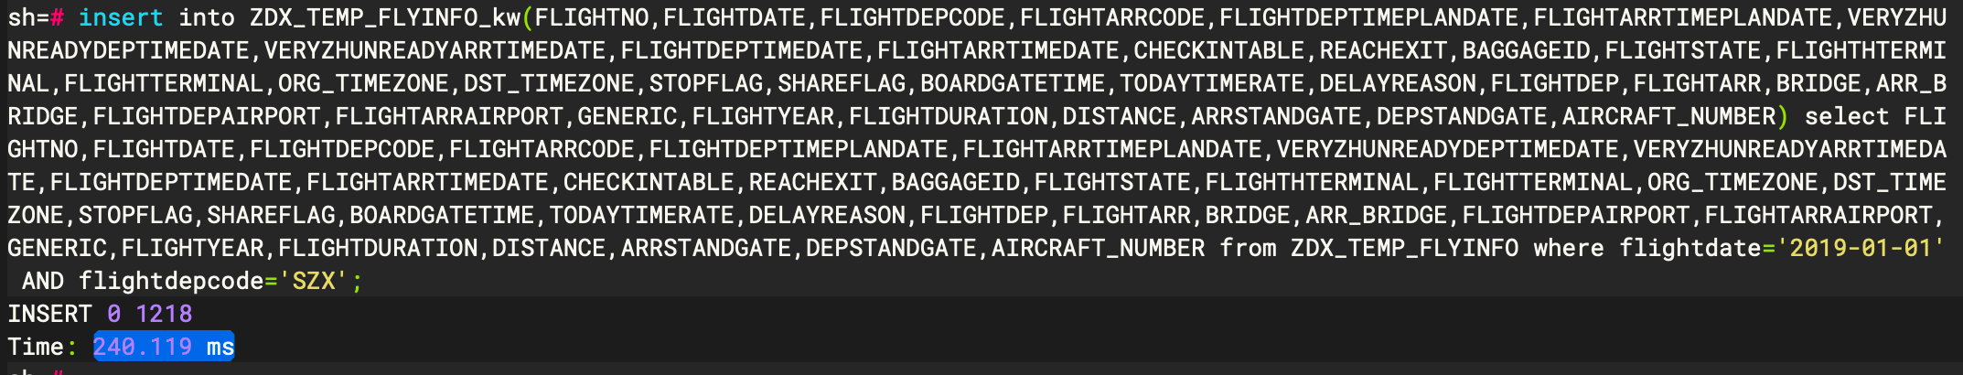开始插入：

|  |
| --- |
| 数据量1218 insert into ZDX_TEMP_FLYINFO_kw(FLIGHTNO,FLIGHTDATE,FLIGHTDEPCODE,FLIGHTARRCODE,FLIGHTDEPTIMEPLANDATE,FLIGHTARRTIMEPLANDATE,VERYZHUNREADYDEPTIMEDATE,VERYZHUNREADYARRTIMEDATE,FLIGHTDEPTIMEDATE,FLIGHTARRTIMEDATE,CHECKINTABLE,REACHEXIT,BAGGAGEID,FLIGHTSTATE,FLIGHTHTERMINAL,FLIGHTTERMINAL,ORG_TIMEZONE,DST_TIMEZONE,STOPFLAG,SHAREFLAG,BOARDGATETIME,TODAYTIMERATE,DELAYREASON,FLIGHTDEP,FLIGHTARR,BRIDGE,ARR_BRIDGE,FLIGHTDEPAIRPORT,FLIGHTARRAIRPORT,GENERIC,FLIGHTYEAR,FLIGHTDURATION,DISTANCE,ARRSTANDGATE,DEPSTANDGATE,AIRCRAFT_NUMBER) select FLIGHTNO,FLIGHTDATE,FLIGHTDEPCODE,FLIGHTARRCODE,FLIGHTDEPTIMEPLANDATE,FLIGHTARRTIMEPLANDATE,VERYZHUNREADYDEPTIMEDATE,VERYZHUNREADYARRTIMEDATE,FLIGHTDEPTIMEDATE,FLIGHTARRTIMEDATE,CHECKINTABLE,REACHEXIT,BAGGAGEID,FLIGHTSTATE,FLIGHTHTERMINAL,FLIGHTTERMINAL,ORG_TIMEZONE,DST_TIMEZONE,STOPFLAG,SHAREFLAG,BOARDGATETIME,TODAYTIMERATE,DELAYREASON,FLIGHTDEP,FLIGHTARR,BRIDGE,ARR_BRIDGE,FLIGHTDEPAIRPORT,FLIGHTARRAIRPORT,GENERIC,FLIGHTYEAR,FLIGHTDURATION,DISTANCE,ARRSTANDGATE,DEPSTANDGATE,AIRCRAFT_NUMBER from ZDX_TEMP_FLYINFO where flightdate='2019-01-01' AND flightdepcode='SZX'; |

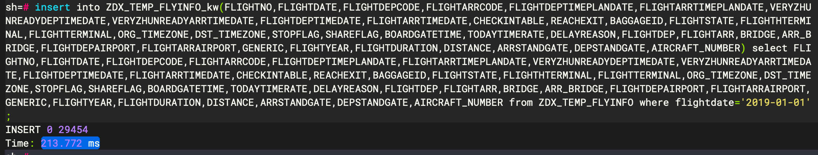

|  |
| --- |
| 数据量 29454 insert into ZDX_TEMP_FLYINFO_kw(FLIGHTNO,FLIGHTDATE,FLIGHTDEPCODE,FLIGHTARRCODE,FLIGHTDEPTIMEPLANDATE,FLIGHTARRTIMEPLANDATE,VERYZHUNREADYDEPTIMEDATE,VERYZHUNREADYARRTIMEDATE,FLIGHTDEPTIMEDATE,FLIGHTARRTIMEDATE,CHECKINTABLE,REACHEXIT,BAGGAGEID,FLIGHTSTATE,FLIGHTHTERMINAL,FLIGHTTERMINAL,ORG_TIMEZONE,DST_TIMEZONE,STOPFLAG,SHAREFLAG,BOARDGATETIME,TODAYTIMERATE,DELAYREASON,FLIGHTDEP,FLIGHTARR,BRIDGE,ARR_BRIDGE,FLIGHTDEPAIRPORT,FLIGHTARRAIRPORT,GENERIC,FLIGHTYEAR,FLIGHTDURATION,DISTANCE,ARRSTANDGATE,DEPSTANDGATE,AIRCRAFT_NUMBER) select FLIGHTNO,FLIGHTDATE,FLIGHTDEPCODE,FLIGHTARRCODE,FLIGHTDEPTIMEPLANDATE,FLIGHTARRTIMEPLANDATE,VERYZHUNREADYDEPTIMEDATE,VERYZHUNREADYARRTIMEDATE,FLIGHTDEPTIMEDATE,FLIGHTARRTIMEDATE,CHECKINTABLE,REACHEXIT,BAGGAGEID,FLIGHTSTATE,FLIGHTHTERMINAL,FLIGHTTERMINAL,ORG_TIMEZONE,DST_TIMEZONE,STOPFLAG,SHAREFLAG,BOARDGATETIME,TODAYTIMERATE,DELAYREASON,FLIGHTDEP,FLIGHTARR,BRIDGE,ARR_BRIDGE,FLIGHTDEPAIRPORT,FLIGHTARRAIRPORT,GENERIC,FLIGHTYEAR,FLIGHTDURATION,DISTANCE,ARRSTANDGATE,DEPSTANDGATE,AIRCRAFT_NUMBER from ZDX_TEMP_FLYINFO where flightdate='2019-01-01'; |

|  |
| --- |
| 数据量441370 insert into ZDX_TEMP_FLYINFO_kw(FLIGHTNO,FLIGHTDATE,FLIGHTDEPCODE,FLIGHTARRCODE,FLIGHTDEPTIMEPLANDATE,FLIGHTARRTIMEPLANDATE,VERYZHUNREADYDEPTIMEDATE,VERYZHUNREADYARRTIMEDATE,FLIGHTDEPTIMEDATE,FLIGHTARRTIMEDATE,CHECKINTABLE,REACHEXIT,BAGGAGEID,FLIGHTSTATE,FLIGHTHTERMINAL,FLIGHTTERMINAL,ORG_TIMEZONE,DST_TIMEZONE,STOPFLAG,SHAREFLAG,BOARDGATETIME,TODAYTIMERATE,DELAYREASON,FLIGHTDEP,FLIGHTARR,BRIDGE,ARR_BRIDGE,FLIGHTDEPAIRPORT,FLIGHTARRAIRPORT,GENERIC,FLIGHTYEAR,FLIGHTDURATION,DISTANCE,ARRSTANDGATE,DEPSTANDGATE,AIRCRAFT_NUMBER) select FLIGHTNO,FLIGHTDATE,FLIGHTDEPCODE,FLIGHTARRCODE,FLIGHTDEPTIMEPLANDATE,FLIGHTARRTIMEPLANDATE,VERYZHUNREADYDEPTIMEDATE,VERYZHUNREADYARRTIMEDATE,FLIGHTDEPTIMEDATE,FLIGHTARRTIMEDATE,CHECKINTABLE,REACHEXIT,BAGGAGEID,FLIGHTSTATE,FLIGHTHTERMINAL,FLIGHTTERMINAL,ORG_TIMEZONE,DST_TIMEZONE,STOPFLAG,SHAREFLAG,BOARDGATETIME,TODAYTIMERATE,DELAYREASON,FLIGHTDEP,FLIGHTARR,BRIDGE,ARR_BRIDGE,FLIGHTDEPAIRPORT,FLIGHTARRAIRPORT,GENERIC,FLIGHTYEAR,FLIGHTDURATION,DISTANCE,ARRSTANDGATE,DEPSTANDGATE,AIRCRAFT_NUMBER from ZDX_TEMP_FLYINFO where flightdate between '2019-01-01' and '2019-01-15'; |

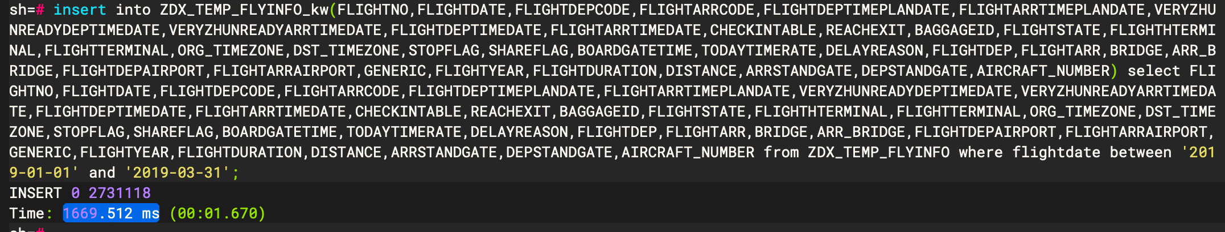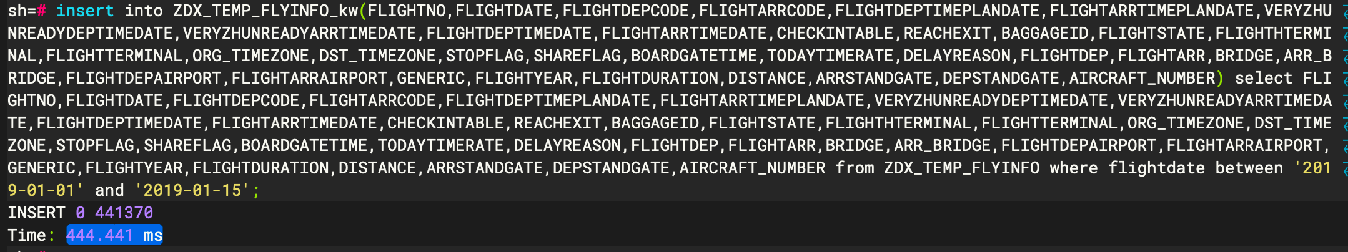

|  |
| --- |
| 数据量2731118 insert into ZDX_TEMP_FLYINFO_kw(FLIGHTNO,FLIGHTDATE,FLIGHTDEPCODE,FLIGHTARRCODE,FLIGHTDEPTIMEPLANDATE,FLIGHTARRTIMEPLANDATE,VERYZHUNREADYDEPTIMEDATE,VERYZHUNREADYARRTIMEDATE,FLIGHTDEPTIMEDATE,FLIGHTARRTIMEDATE,CHECKINTABLE,REACHEXIT,BAGGAGEID,FLIGHTSTATE,FLIGHTHTERMINAL,FLIGHTTERMINAL,ORG_TIMEZONE,DST_TIMEZONE,STOPFLAG,SHAREFLAG,BOARDGATETIME,TODAYTIMERATE,DELAYREASON,FLIGHTDEP,FLIGHTARR,BRIDGE,ARR_BRIDGE,FLIGHTDEPAIRPORT,FLIGHTARRAIRPORT,GENERIC,FLIGHTYEAR,FLIGHTDURATION,DISTANCE,ARRSTANDGATE,DEPSTANDGATE,AIRCRAFT_NUMBER) select FLIGHTNO,FLIGHTDATE,FLIGHTDEPCODE,FLIGHTARRCODE,FLIGHTDEPTIMEPLANDATE,FLIGHTARRTIMEPLANDATE,VERYZHUNREADYDEPTIMEDATE,VERYZHUNREADYARRTIMEDATE,FLIGHTDEPTIMEDATE,FLIGHTARRTIMEDATE,CHECKINTABLE,REACHEXIT,BAGGAGEID,FLIGHTSTATE,FLIGHTHTERMINAL,FLIGHTTERMINAL,ORG_TIMEZONE,DST_TIMEZONE,STOPFLAG,SHAREFLAG,BOARDGATETIME,TODAYTIMERATE,DELAYREASON,FLIGHTDEP,FLIGHTARR,BRIDGE,ARR_BRIDGE,FLIGHTDEPAIRPORT,FLIGHTARRAIRPORT,GENERIC,FLIGHTYEAR,FLIGHTDURATION,DISTANCE,ARRSTANDGATE,DEPSTANDGATE,AIRCRAFT_NUMBER from ZDX_TEMP_FLYINFO where flightdate between '2019-01-01' and '2019-03-31'; |

|  |
| --- |
| 数据量10850431 insert into ZDX_TEMP_FLYINFO_kw(FLIGHTNO,FLIGHTDATE,FLIGHTDEPCODE,FLIGHTARRCODE,FLIGHTDEPTIMEPLANDATE,FLIGHTARRTIMEPLANDATE,VERYZHUNREADYDEPTIMEDATE,VERYZHUNREADYARRTIMEDATE,FLIGHTDEPTIMEDATE,FLIGHTARRTIMEDATE,CHECKINTABLE,REACHEXIT,BAGGAGEID,FLIGHTSTATE,FLIGHTHTERMINAL,FLIGHTTERMINAL,ORG_TIMEZONE,DST_TIMEZONE,STOPFLAG,SHAREFLAG,BOARDGATETIME,TODAYTIMERATE,DELAYREASON,FLIGHTDEP,FLIGHTARR,BRIDGE,ARR_BRIDGE,FLIGHTDEPAIRPORT,FLIGHTARRAIRPORT,GENERIC,FLIGHTYEAR,FLIGHTDURATION,DISTANCE,ARRSTANDGATE,DEPSTANDGATE,AIRCRAFT_NUMBER) select FLIGHTNO,FLIGHTDATE,FLIGHTDEPCODE,FLIGHTARRCODE,FLIGHTDEPTIMEPLANDATE,FLIGHTARRTIMEPLANDATE,VERYZHUNREADYDEPTIMEDATE,VERYZHUNREADYARRTIMEDATE,FLIGHTDEPTIMEDATE,FLIGHTARRTIMEDATE,CHECKINTABLE,REACHEXIT,BAGGAGEID,FLIGHTSTATE,FLIGHTHTERMINAL,FLIGHTTERMINAL,ORG_TIMEZONE,DST_TIMEZONE,STOPFLAG,SHAREFLAG,BOARDGATETIME,TODAYTIMERATE,DELAYREASON,FLIGHTDEP,FLIGHTARR,BRIDGE,ARR_BRIDGE,FLIGHTDEPAIRPORT,FLIGHTARRAIRPORT,GENERIC,FLIGHTYEAR,FLIGHTDURATION,DISTANCE,ARRSTANDGATE,DEPSTANDGATE,AIRCRAFT_NUMBER from ZDX_TEMP_FLYINFO where flightdate between '2019-01-01' and '2019-12-31'; |

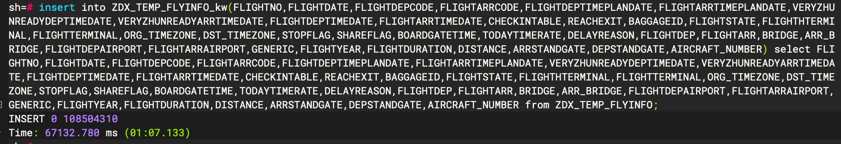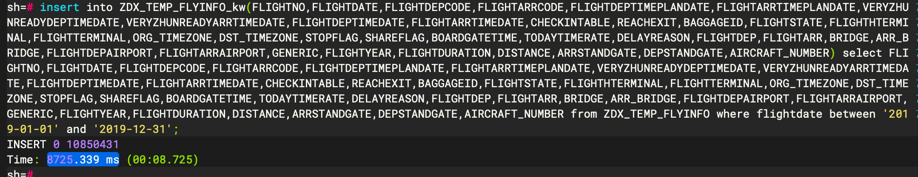

|  |
| --- |
| 数据量108504310 insert into ZDX_TEMP_FLYINFO_kw(FLIGHTNO,FLIGHTDATE,FLIGHTDEPCODE,FLIGHTARRCODE,FLIGHTDEPTIMEPLANDATE,FLIGHTARRTIMEPLANDATE,VERYZHUNREADYDEPTIMEDATE,VERYZHUNREADYARRTIMEDATE,FLIGHTDEPTIMEDATE,FLIGHTARRTIMEDATE,CHECKINTABLE,REACHEXIT,BAGGAGEID,FLIGHTSTATE,FLIGHTHTERMINAL,FLIGHTTERMINAL,ORG_TIMEZONE,DST_TIMEZONE,STOPFLAG,SHAREFLAG,BOARDGATETIME,TODAYTIMERATE,DELAYREASON,FLIGHTDEP,FLIGHTARR,BRIDGE,ARR_BRIDGE,FLIGHTDEPAIRPORT,FLIGHTARRAIRPORT,GENERIC,FLIGHTYEAR,FLIGHTDURATION,DISTANCE,ARRSTANDGATE,DEPSTANDGATE,AIRCRAFT_NUMBER) select FLIGHTNO,FLIGHTDATE,FLIGHTDEPCODE,FLIGHTARRCODE,FLIGHTDEPTIMEPLANDATE,FLIGHTARRTIMEPLANDATE,VERYZHUNREADYDEPTIMEDATE,VERYZHUNREADYARRTIMEDATE,FLIGHTDEPTIMEDATE,FLIGHTARRTIMEDATE,CHECKINTABLE,REACHEXIT,BAGGAGEID,FLIGHTSTATE,FLIGHTHTERMINAL,FLIGHTTERMINAL,ORG_TIMEZONE,DST_TIMEZONE,STOPFLAG,SHAREFLAG,BOARDGATETIME,TODAYTIMERATE,DELAYREASON,FLIGHTDEP,FLIGHTARR,BRIDGE,ARR_BRIDGE,FLIGHTDEPAIRPORT,FLIGHTARRAIRPORT,GENERIC,FLIGHTYEAR,FLIGHTDURATION,DISTANCE,ARRSTANDGATE,DEPSTANDGATE,AIRCRAFT_NUMBER from ZDX_TEMP_FLYINFO; |

**千万数据有索引插入**

﻿建立一个已有千万级数量的表，有索引，分别插入各量级数据，记录各自插入的时间。

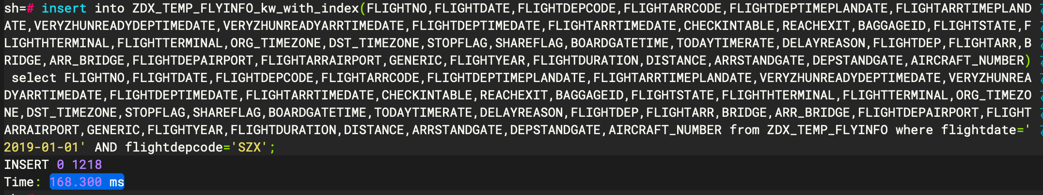

|  |
| --- |
| 数据量1218 insert into ZDX_TEMP_FLYINFO_kw_with_index(FLIGHTNO,FLIGHTDATE,FLIGHTDEPCODE,FLIGHTARRCODE,FLIGHTDEPTIMEPLANDATE,FLIGHTARRTIMEPLANDATE,VERYZHUNREADYDEPTIMEDATE,VERYZHUNREADYARRTIMEDATE,FLIGHTDEPTIMEDATE,FLIGHTARRTIMEDATE,CHECKINTABLE,REACHEXIT,BAGGAGEID,FLIGHTSTATE,FLIGHTHTERMINAL,FLIGHTTERMINAL,ORG_TIMEZONE,DST_TIMEZONE,STOPFLAG,SHAREFLAG,BOARDGATETIME,TODAYTIMERATE,DELAYREASON,FLIGHTDEP,FLIGHTARR,BRIDGE,ARR_BRIDGE,FLIGHTDEPAIRPORT,FLIGHTARRAIRPORT,GENERIC,FLIGHTYEAR,FLIGHTDURATION,DISTANCE,ARRSTANDGATE,DEPSTANDGATE,AIRCRAFT_NUMBER) select FLIGHTNO,FLIGHTDATE,FLIGHTDEPCODE,FLIGHTARRCODE,FLIGHTDEPTIMEPLANDATE,FLIGHTARRTIMEPLANDATE,VERYZHUNREADYDEPTIMEDATE,VERYZHUNREADYARRTIMEDATE,FLIGHTDEPTIMEDATE,FLIGHTARRTIMEDATE,CHECKINTABLE,REACHEXIT,BAGGAGEID,FLIGHTSTATE,FLIGHTHTERMINAL,FLIGHTTERMINAL,ORG_TIMEZONE,DST_TIMEZONE,STOPFLAG,SHAREFLAG,BOARDGATETIME,TODAYTIMERATE,DELAYREASON,FLIGHTDEP,FLIGHTARR,BRIDGE,ARR_BRIDGE,FLIGHTDEPAIRPORT,FLIGHTARRAIRPORT,GENERIC,FLIGHTYEAR,FLIGHTDURATION,DISTANCE,ARRSTANDGATE,DEPSTANDGATE,AIRCRAFT_NUMBER from ZDX_TEMP_FLYINFO where flightdate='2019-01-01' AND flightdepcode='SZX'; |

|  |
| --- |
| 数据量 29454 insert into ZDX_TEMP_FLYINFO_kw_with_index(FLIGHTNO,FLIGHTDATE,FLIGHTDEPCODE,FLIGHTARRCODE,FLIGHTDEPTIMEPLANDATE,FLIGHTARRTIMEPLANDATE,VERYZHUNREADYDEPTIMEDATE,VERYZHUNREADYARRTIMEDATE,FLIGHTDEPTIMEDATE,FLIGHTARRTIMEDATE,CHECKINTABLE,REACHEXIT,BAGGAGEID,FLIGHTSTATE,FLIGHTHTERMINAL,FLIGHTTERMINAL,ORG_TIMEZONE,DST_TIMEZONE,STOPFLAG,SHAREFLAG,BOARDGATETIME,TODAYTIMERATE,DELAYREASON,FLIGHTDEP,FLIGHTARR,BRIDGE,ARR_BRIDGE,FLIGHTDEPAIRPORT,FLIGHTARRAIRPORT,GENERIC,FLIGHTYEAR,FLIGHTDURATION,DISTANCE,ARRSTANDGATE,DEPSTANDGATE,AIRCRAFT_NUMBER) select FLIGHTNO,FLIGHTDATE,FLIGHTDEPCODE,FLIGHTARRCODE,FLIGHTDEPTIMEPLANDATE,FLIGHTARRTIMEPLANDATE,VERYZHUNREADYDEPTIMEDATE,VERYZHUNREADYARRTIMEDATE,FLIGHTDEPTIMEDATE,FLIGHTARRTIMEDATE,CHECKINTABLE,REACHEXIT,BAGGAGEID,FLIGHTSTATE,FLIGHTHTERMINAL,FLIGHTTERMINAL,ORG_TIMEZONE,DST_TIMEZONE,STOPFLAG,SHAREFLAG,BOARDGATETIME,TODAYTIMERATE,DELAYREASON,FLIGHTDEP,FLIGHTARR,BRIDGE,ARR_BRIDGE,FLIGHTDEPAIRPORT,FLIGHTARRAIRPORT,GENERIC,FLIGHTYEAR,FLIGHTDURATION,DISTANCE,ARRSTANDGATE,DEPSTANDGATE,AIRCRAFT_NUMBER from ZDX_TEMP_FLYINFO where flightdate='2019-01-01'; |

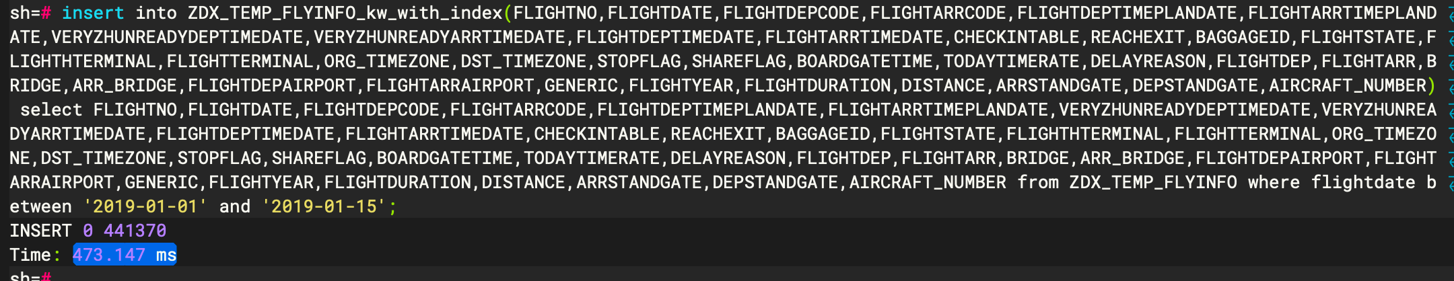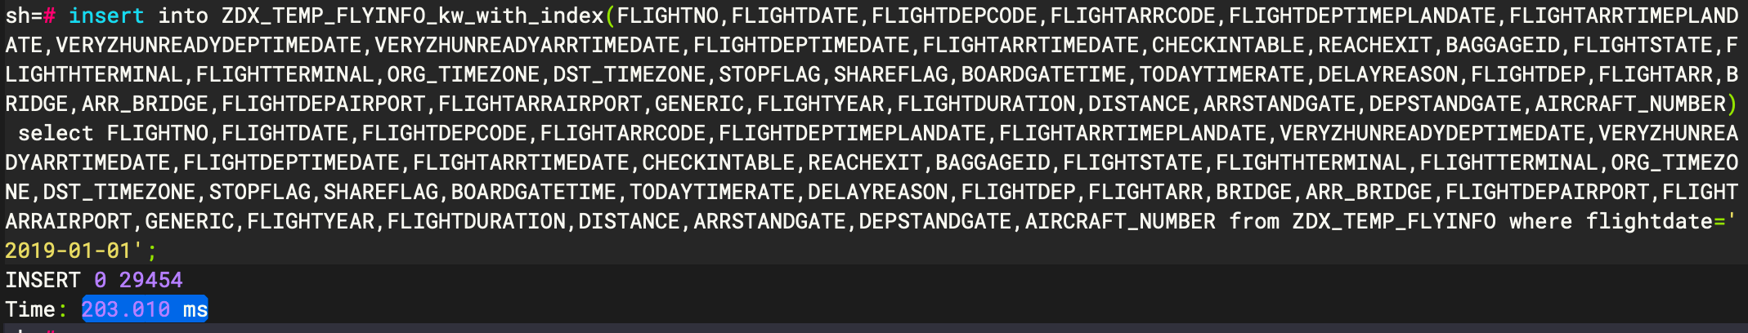

|  |
| --- |
| 数据量441370 insert into ZDX_TEMP_FLYINFO_kw_with_index(FLIGHTNO,FLIGHTDATE,FLIGHTDEPCODE,FLIGHTARRCODE,FLIGHTDEPTIMEPLANDATE,FLIGHTARRTIMEPLANDATE,VERYZHUNREADYDEPTIMEDATE,VERYZHUNREADYARRTIMEDATE,FLIGHTDEPTIMEDATE,FLIGHTARRTIMEDATE,CHECKINTABLE,REACHEXIT,BAGGAGEID,FLIGHTSTATE,FLIGHTHTERMINAL,FLIGHTTERMINAL,ORG_TIMEZONE,DST_TIMEZONE,STOPFLAG,SHAREFLAG,BOARDGATETIME,TODAYTIMERATE,DELAYREASON,FLIGHTDEP,FLIGHTARR,BRIDGE,ARR_BRIDGE,FLIGHTDEPAIRPORT,FLIGHTARRAIRPORT,GENERIC,FLIGHTYEAR,FLIGHTDURATION,DISTANCE,ARRSTANDGATE,DEPSTANDGATE,AIRCRAFT_NUMBER) select FLIGHTNO,FLIGHTDATE,FLIGHTDEPCODE,FLIGHTARRCODE,FLIGHTDEPTIMEPLANDATE,FLIGHTARRTIMEPLANDATE,VERYZHUNREADYDEPTIMEDATE,VERYZHUNREADYARRTIMEDATE,FLIGHTDEPTIMEDATE,FLIGHTARRTIMEDATE,CHECKINTABLE,REACHEXIT,BAGGAGEID,FLIGHTSTATE,FLIGHTHTERMINAL,FLIGHTTERMINAL,ORG_TIMEZONE,DST_TIMEZONE,STOPFLAG,SHAREFLAG,BOARDGATETIME,TODAYTIMERATE,DELAYREASON,FLIGHTDEP,FLIGHTARR,BRIDGE,ARR_BRIDGE,FLIGHTDEPAIRPORT,FLIGHTARRAIRPORT,GENERIC,FLIGHTYEAR,FLIGHTDURATION,DISTANCE,ARRSTANDGATE,DEPSTANDGATE,AIRCRAFT_NUMBER from ZDX_TEMP_FLYINFO where flightdate between '2019-01-01' and '2019-01-15'; |

|  |
| --- |
| 数据量2731118 insert into ZDX_TEMP_FLYINFO_kw_with_index(FLIGHTNO,FLIGHTDATE,FLIGHTDEPCODE,FLIGHTARRCODE,FLIGHTDEPTIMEPLANDATE,FLIGHTARRTIMEPLANDATE,VERYZHUNREADYDEPTIMEDATE,VERYZHUNREADYARRTIMEDATE,FLIGHTDEPTIMEDATE,FLIGHTARRTIMEDATE,CHECKINTABLE,REACHEXIT,BAGGAGEID,FLIGHTSTATE,FLIGHTHTERMINAL,FLIGHTTERMINAL,ORG_TIMEZONE,DST_TIMEZONE,STOPFLAG,SHAREFLAG,BOARDGATETIME,TODAYTIMERATE,DELAYREASON,FLIGHTDEP,FLIGHTARR,BRIDGE,ARR_BRIDGE,FLIGHTDEPAIRPORT,FLIGHTARRAIRPORT,GENERIC,FLIGHTYEAR,FLIGHTDURATION,DISTANCE,ARRSTANDGATE,DEPSTANDGATE,AIRCRAFT_NUMBER) select FLIGHTNO,FLIGHTDATE,FLIGHTDEPCODE,FLIGHTARRCODE,FLIGHTDEPTIMEPLANDATE,FLIGHTARRTIMEPLANDATE,VERYZHUNREADYDEPTIMEDATE,VERYZHUNREADYARRTIMEDATE,FLIGHTDEPTIMEDATE,FLIGHTARRTIMEDATE,CHECKINTABLE,REACHEXIT,BAGGAGEID,FLIGHTSTATE,FLIGHTHTERMINAL,FLIGHTTERMINAL,ORG_TIMEZONE,DST_TIMEZONE,STOPFLAG,SHAREFLAG,BOARDGATETIME,TODAYTIMERATE,DELAYREASON,FLIGHTDEP,FLIGHTARR,BRIDGE,ARR_BRIDGE,FLIGHTDEPAIRPORT,FLIGHTARRAIRPORT,GENERIC,FLIGHTYEAR,FLIGHTDURATION,DISTANCE,ARRSTANDGATE,DEPSTANDGATE,AIRCRAFT_NUMBER from ZDX_TEMP_FLYINFO where flightdate between '2019-01-01' and '2019-03-31'; |

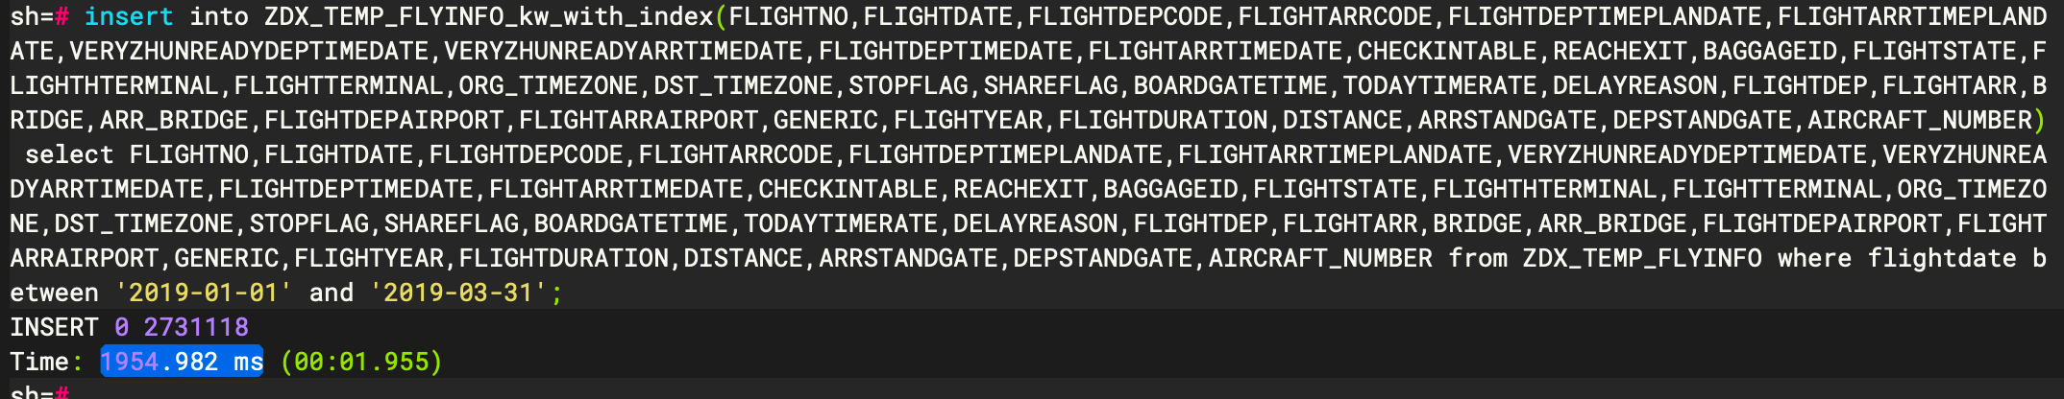

|  |
| --- |
| 数据量10850431 insert into ZDX_TEMP_FLYINFO_kw_with_index(FLIGHTNO,FLIGHTDATE,FLIGHTDEPCODE,FLIGHTARRCODE,FLIGHTDEPTIMEPLANDATE,FLIGHTARRTIMEPLANDATE,VERYZHUNREADYDEPTIMEDATE,VERYZHUNREADYARRTIMEDATE,FLIGHTDEPTIMEDATE,FLIGHTARRTIMEDATE,CHECKINTABLE,REACHEXIT,BAGGAGEID,FLIGHTSTATE,FLIGHTHTERMINAL,FLIGHTTERMINAL,ORG_TIMEZONE,DST_TIMEZONE,STOPFLAG,SHAREFLAG,BOARDGATETIME,TODAYTIMERATE,DELAYREASON,FLIGHTDEP,FLIGHTARR,BRIDGE,ARR_BRIDGE,FLIGHTDEPAIRPORT,FLIGHTARRAIRPORT,GENERIC,FLIGHTYEAR,FLIGHTDURATION,DISTANCE,ARRSTANDGATE,DEPSTANDGATE,AIRCRAFT_NUMBER) select FLIGHTNO,FLIGHTDATE,FLIGHTDEPCODE,FLIGHTARRCODE,FLIGHTDEPTIMEPLANDATE,FLIGHTARRTIMEPLANDATE,VERYZHUNREADYDEPTIMEDATE,VERYZHUNREADYARRTIMEDATE,FLIGHTDEPTIMEDATE,FLIGHTARRTIMEDATE,CHECKINTABLE,REACHEXIT,BAGGAGEID,FLIGHTSTATE,FLIGHTHTERMINAL,FLIGHTTERMINAL,ORG_TIMEZONE,DST_TIMEZONE,STOPFLAG,SHAREFLAG,BOARDGATETIME,TODAYTIMERATE,DELAYREASON,FLIGHTDEP,FLIGHTARR,BRIDGE,ARR_BRIDGE,FLIGHTDEPAIRPORT,FLIGHTARRAIRPORT,GENERIC,FLIGHTYEAR,FLIGHTDURATION,DISTANCE,ARRSTANDGATE,DEPSTANDGATE,AIRCRAFT_NUMBER from ZDX_TEMP_FLYINFO where flightdate between '2019-01-01' and '2019-12-31'; |

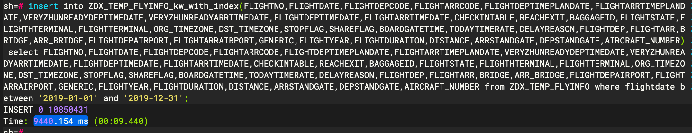

|  |
| --- |
| 数据量108504310 insert into ZDX_TEMP_FLYINFO_kw_with_index(FLIGHTNO,FLIGHTDATE,FLIGHTDEPCODE,FLIGHTARRCODE,FLIGHTDEPTIMEPLANDATE,FLIGHTARRTIMEPLANDATE,VERYZHUNREADYDEPTIMEDATE,VERYZHUNREADYARRTIMEDATE,FLIGHTDEPTIMEDATE,FLIGHTARRTIMEDATE,CHECKINTABLE,REACHEXIT,BAGGAGEID,FLIGHTSTATE,FLIGHTHTERMINAL,FLIGHTTERMINAL,ORG_TIMEZONE,DST_TIMEZONE,STOPFLAG,SHAREFLAG,BOARDGATETIME,TODAYTIMERATE,DELAYREASON,FLIGHTDEP,FLIGHTARR,BRIDGE,ARR_BRIDGE,FLIGHTDEPAIRPORT,FLIGHTARRAIRPORT,GENERIC,FLIGHTYEAR,FLIGHTDURATION,DISTANCE,ARRSTANDGATE,DEPSTANDGATE,AIRCRAFT_NUMBER) select FLIGHTNO,FLIGHTDATE,FLIGHTDEPCODE,FLIGHTARRCODE,FLIGHTDEPTIMEPLANDATE,FLIGHTARRTIMEPLANDATE,VERYZHUNREADYDEPTIMEDATE,VERYZHUNREADYARRTIMEDATE,FLIGHTDEPTIMEDATE,FLIGHTARRTIMEDATE,CHECKINTABLE,REACHEXIT,BAGGAGEID,FLIGHTSTATE,FLIGHTHTERMINAL,FLIGHTTERMINAL,ORG_TIMEZONE,DST_TIMEZONE,STOPFLAG,SHAREFLAG,BOARDGATETIME,TODAYTIMERATE,DELAYREASON,FLIGHTDEP,FLIGHTARR,BRIDGE,ARR_BRIDGE,FLIGHTDEPAIRPORT,FLIGHTARRAIRPORT,GENERIC,FLIGHTYEAR,FLIGHTDURATION,DISTANCE,ARRSTANDGATE,DEPSTANDGATE,AIRCRAFT_NUMBER from ZDX_TEMP_FLYINFO; |

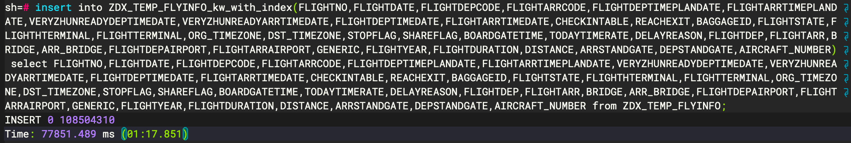

1. **单表查询**

在各量级数据表（有索引、无索引），分别执行以下语句，记录查询时间：

|  |
| --- |
| select * from zdx_temp_flyinfo t  where t.flightdate between '2019-01-01' and '2019-12-31'  and t.flightdepcode='SZX' and t.flightarrcode='PEK'; |

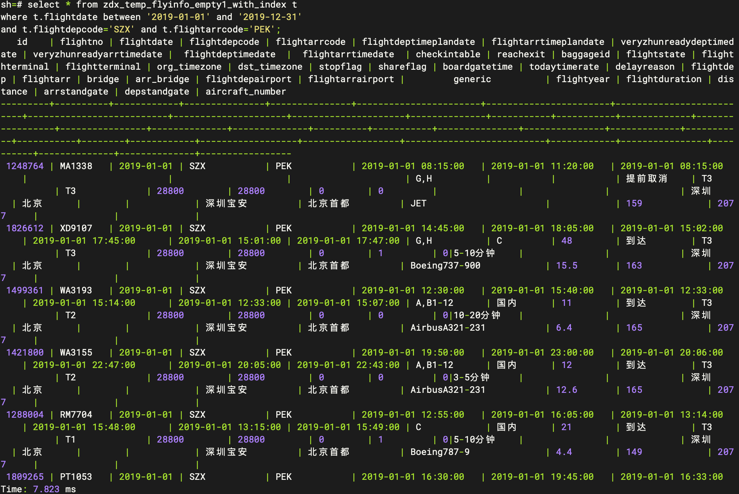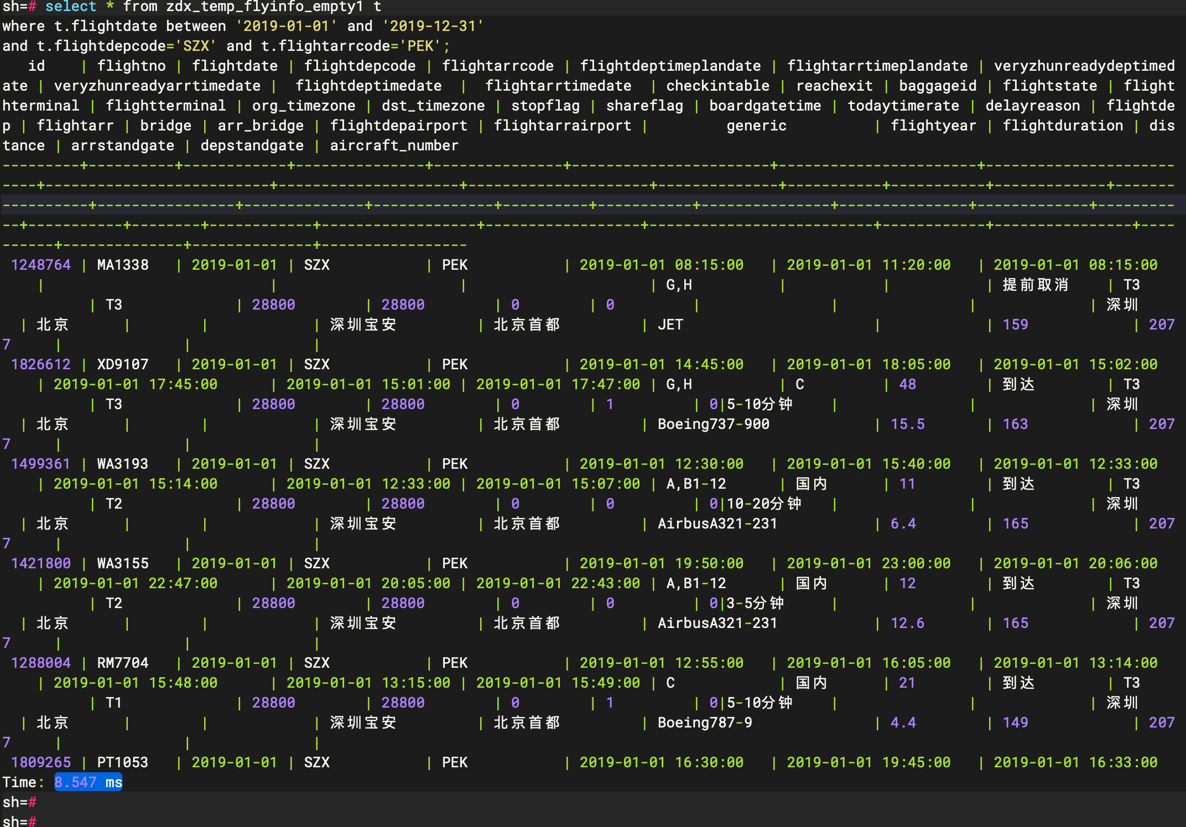执行查询：

|  |
| --- |
| 数据量1218 select * from zdx_temp_flyinfo_empty1 t where t.flightdate between '2019-01-01' and '2019-12-31'  and t.flightdepcode='SZX' and t.flightarrcode='PEK'; |

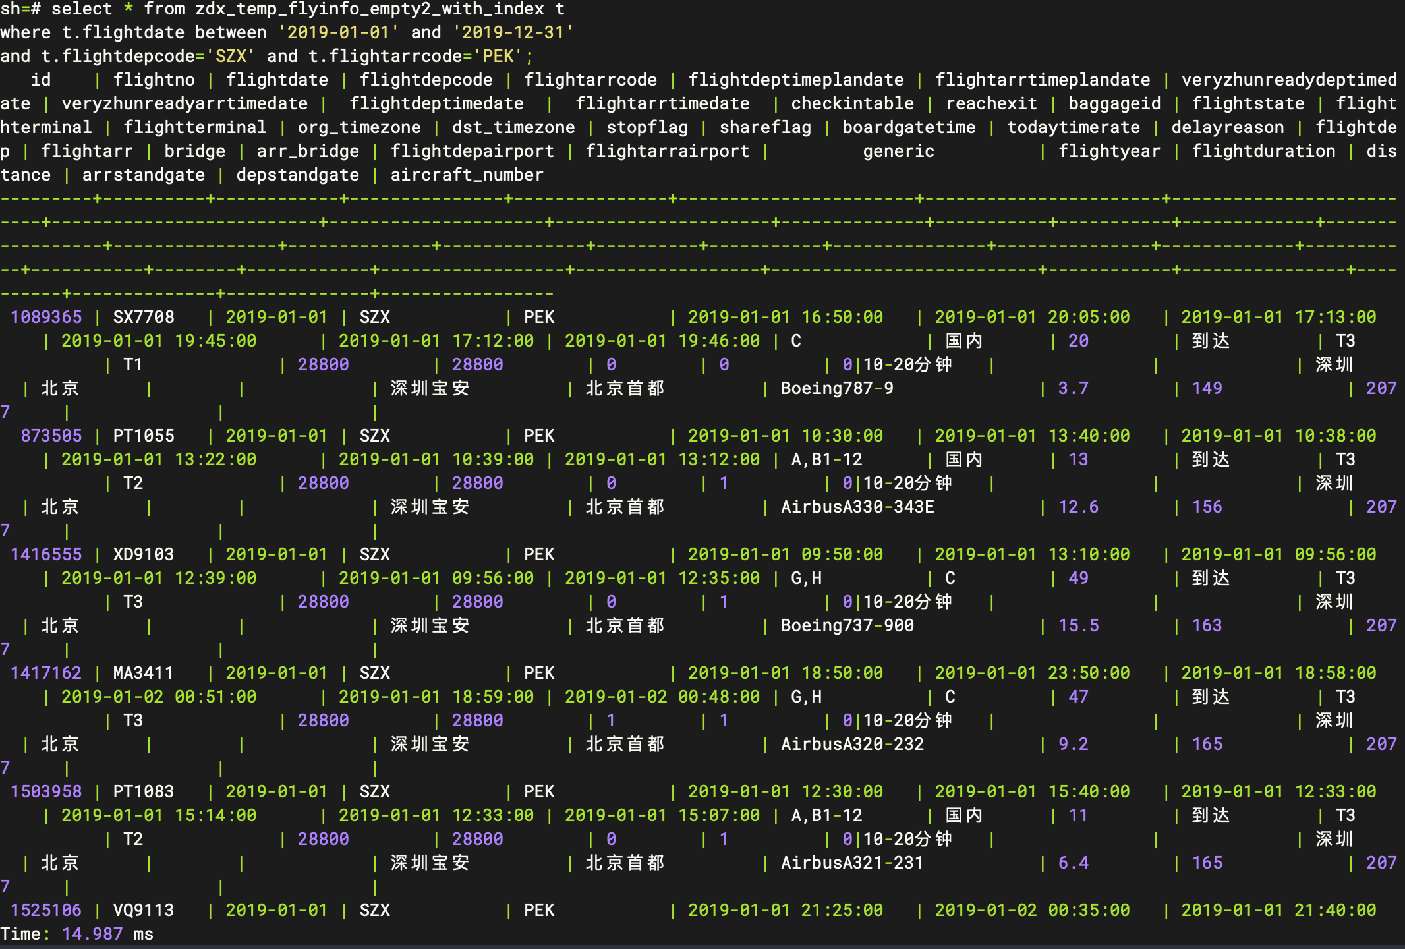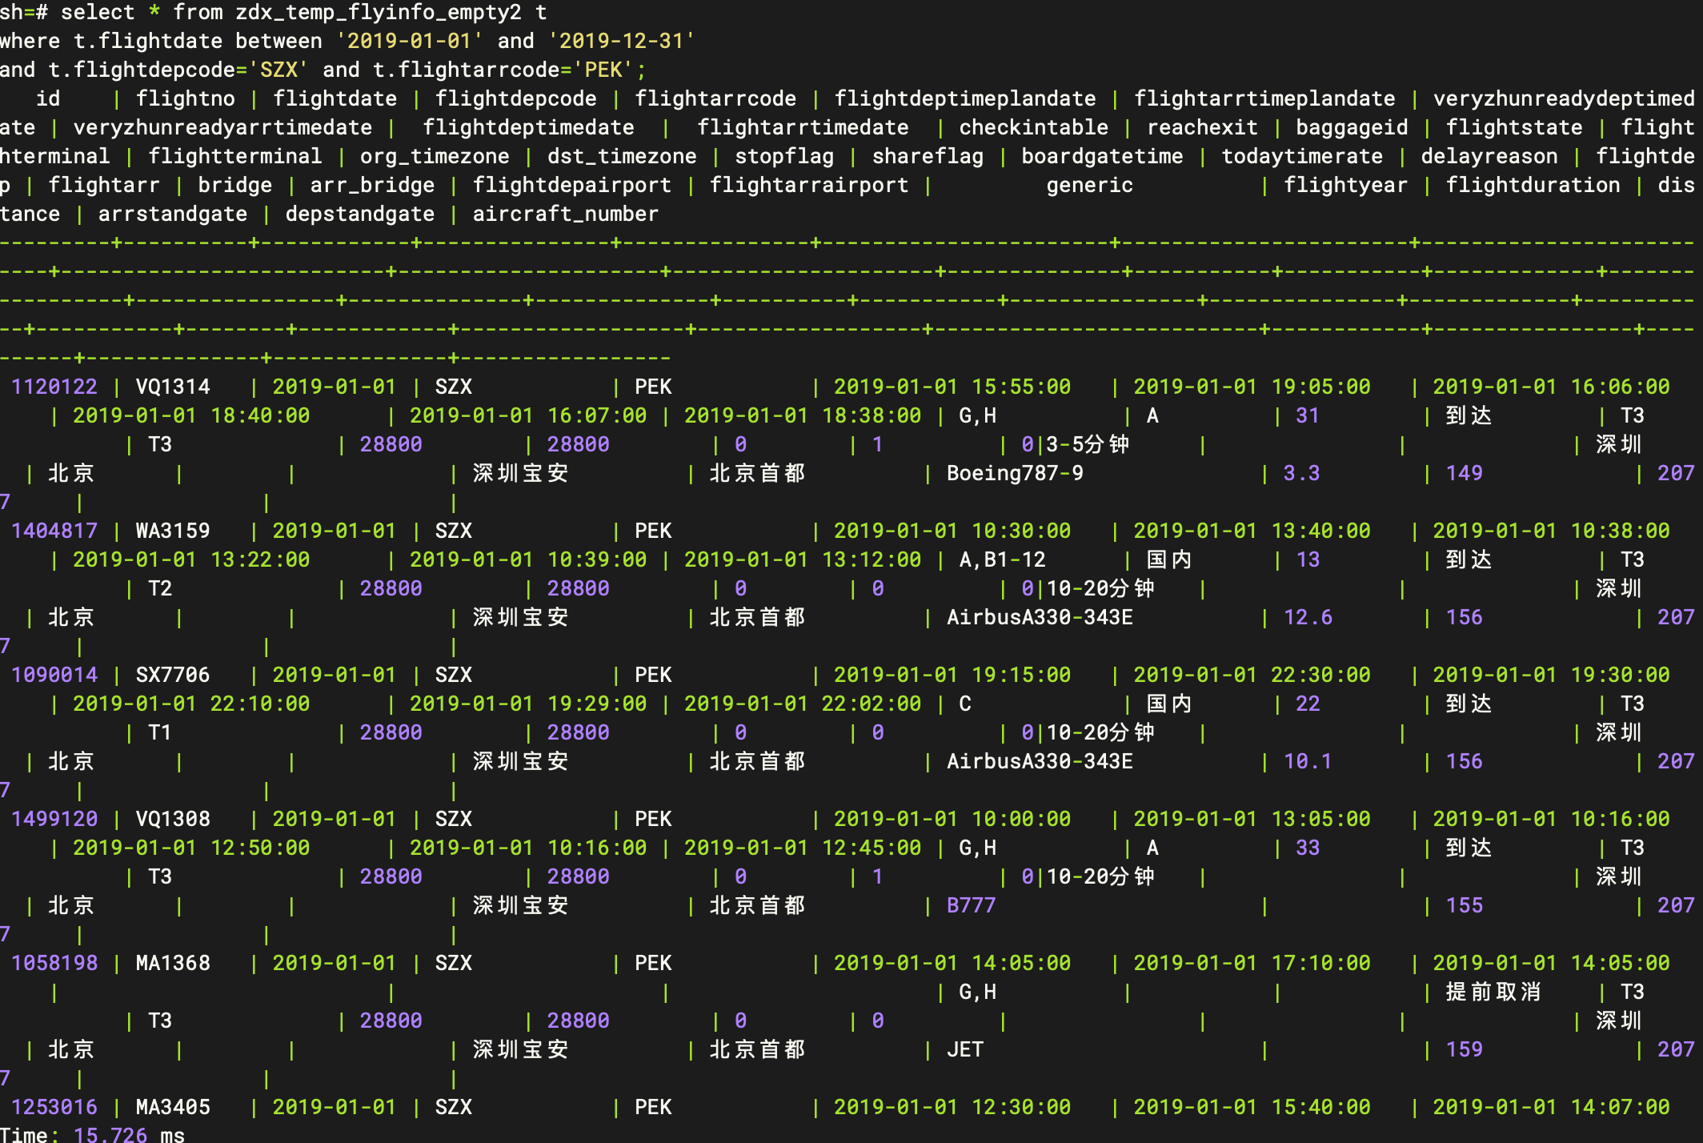

|  |
| --- |
| 数据量 29454 select * from zdx_temp_flyinfo_empty2 t where t.flightdate between '2019-01-01' and '2019-12-31'  and t.flightdepcode='SZX' and t.flightarrcode='PEK'; |

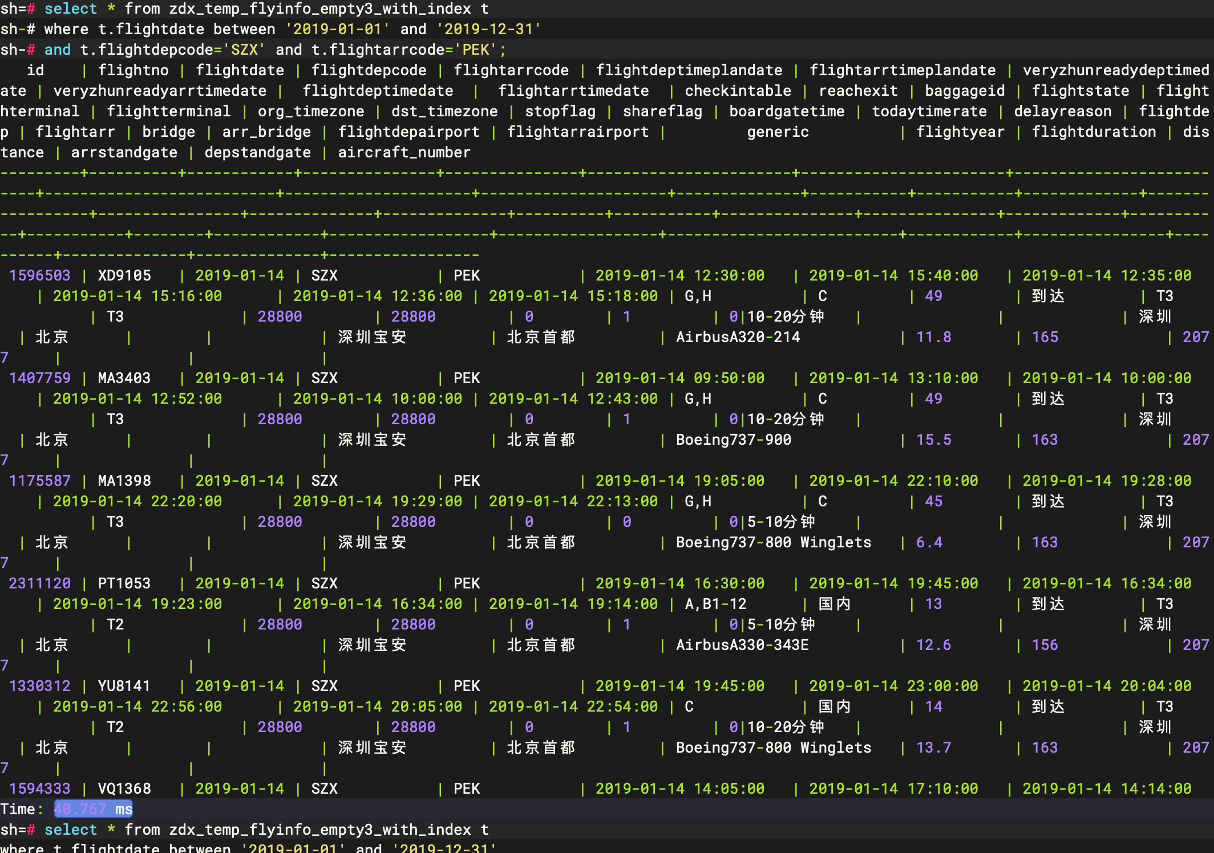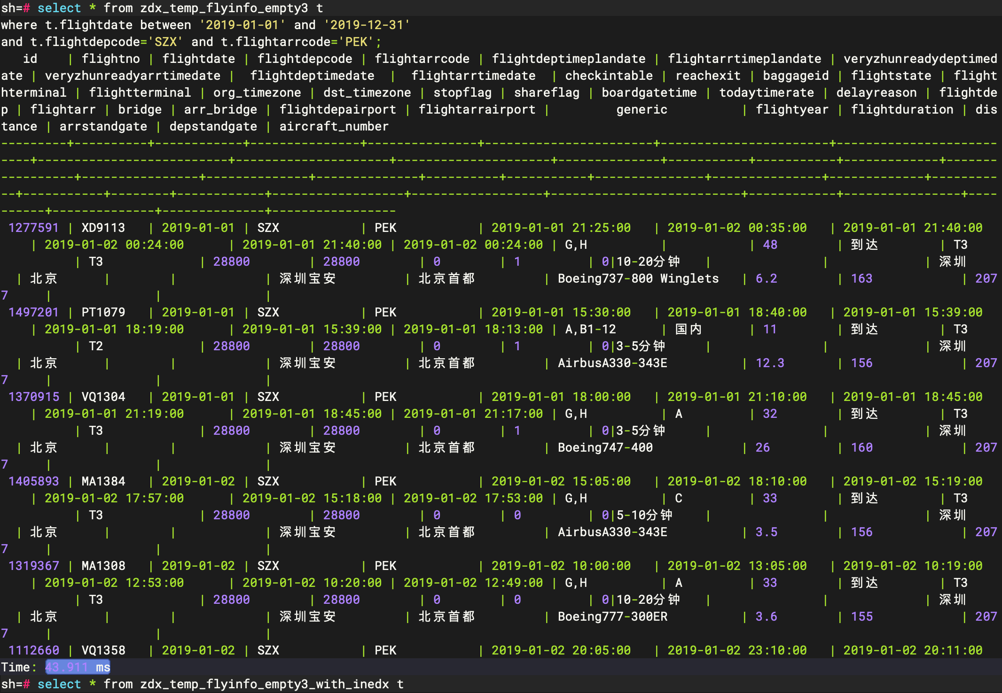

|  |
| --- |
| 数据量441370 select * from zdx_temp_flyinfo_empty3 t where t.flightdate between '2019-01-01' and '2019-12-31'  and t.flightdepcode='SZX' and t.flightarrcode='PEK'; |

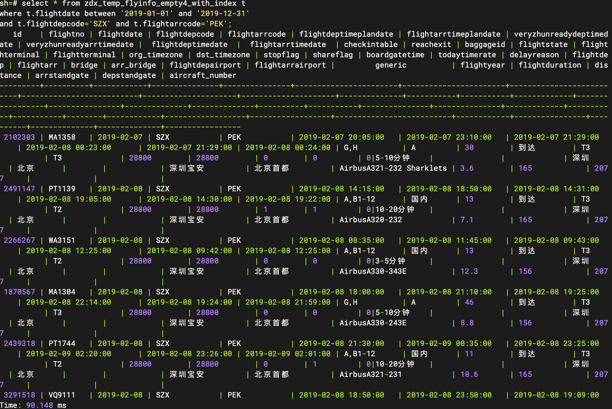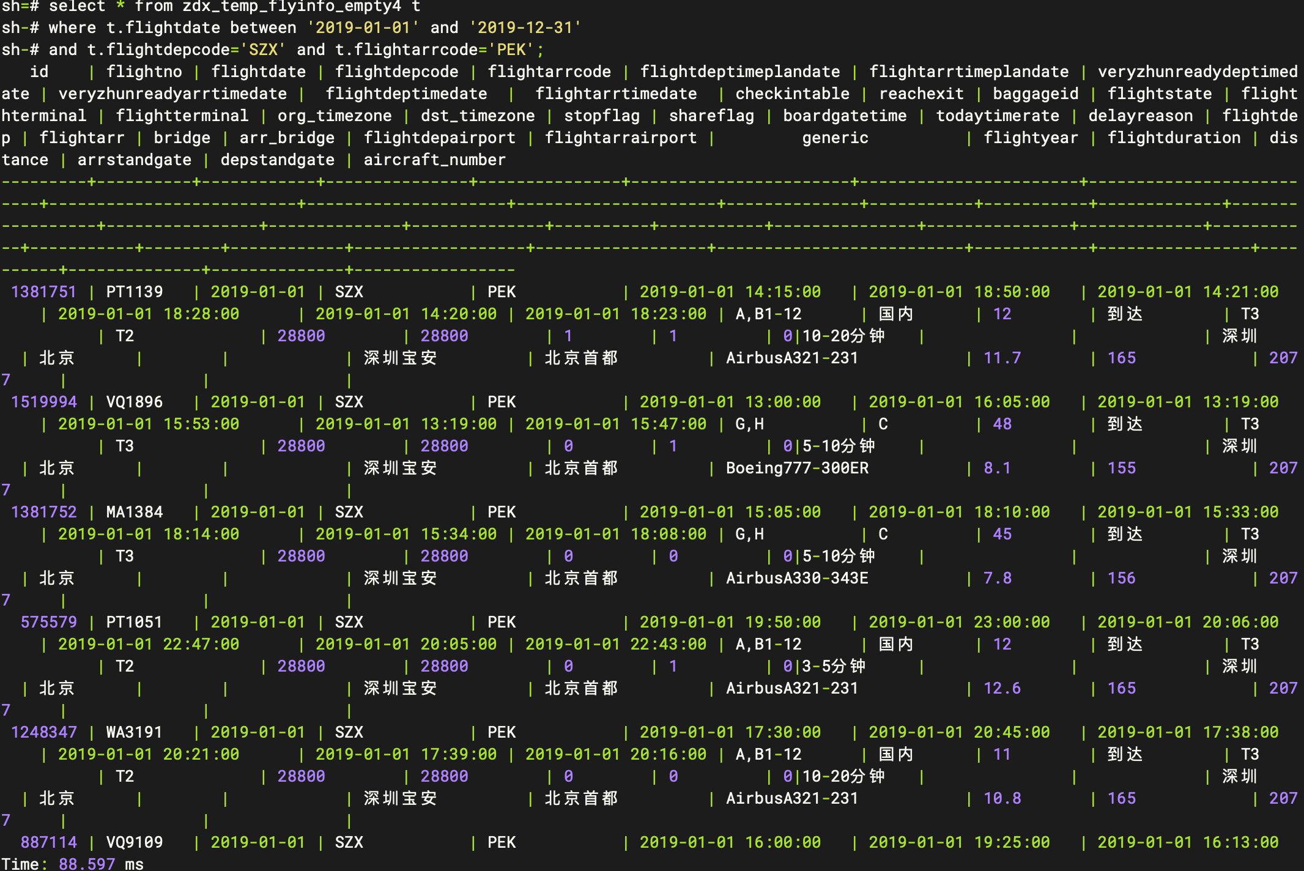

|  |
| --- |
| 数据量2731118 select * from zdx_temp_flyinfo_empty4 t where t.flightdate between '2019-01-01' and '2019-12-31'  and t.flightdepcode='SZX' and t.flightarrcode='PEK'; |

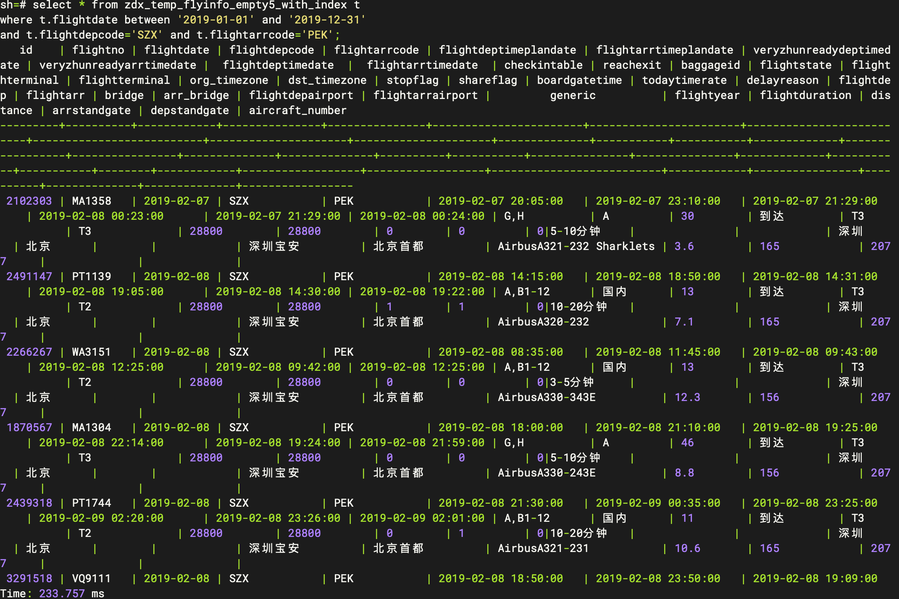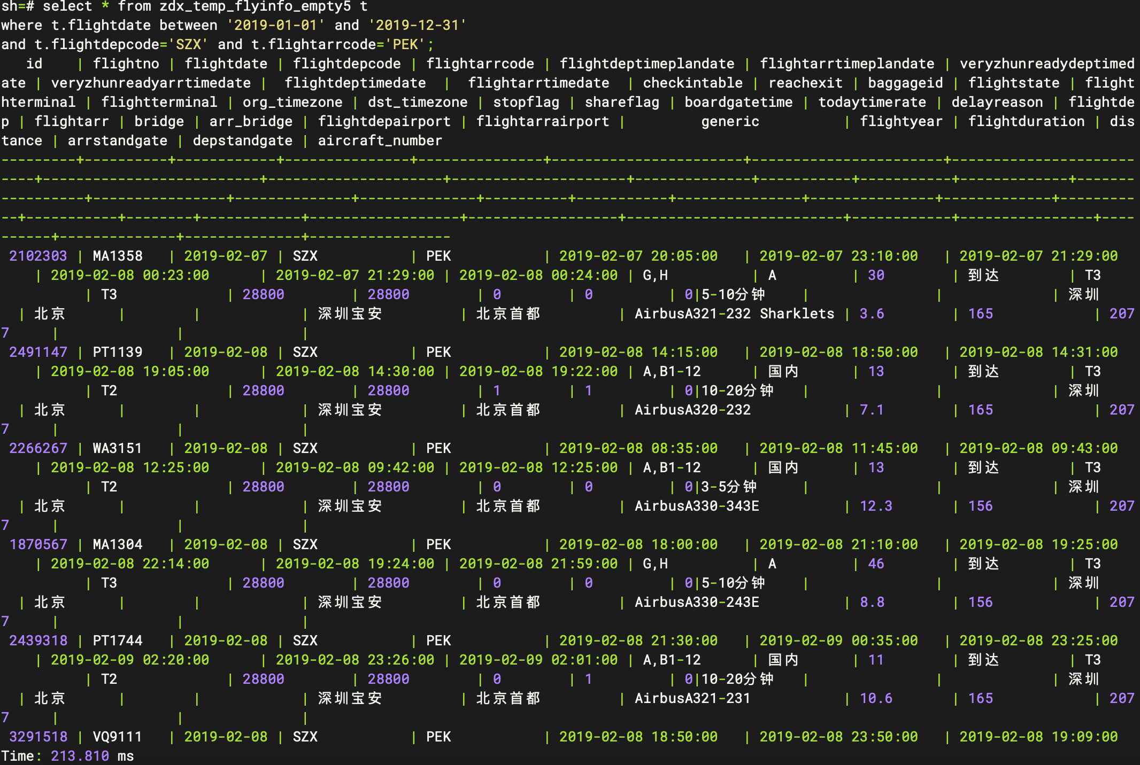

|  |
| --- |
| 数据量10850431 select * from zdx_temp_flyinfo_empty5 t where t.flightdate between '2019-01-01' and '2019-12-31'  and t.flightdepcode='SZX' and t.flightarrcode='PEK'; |

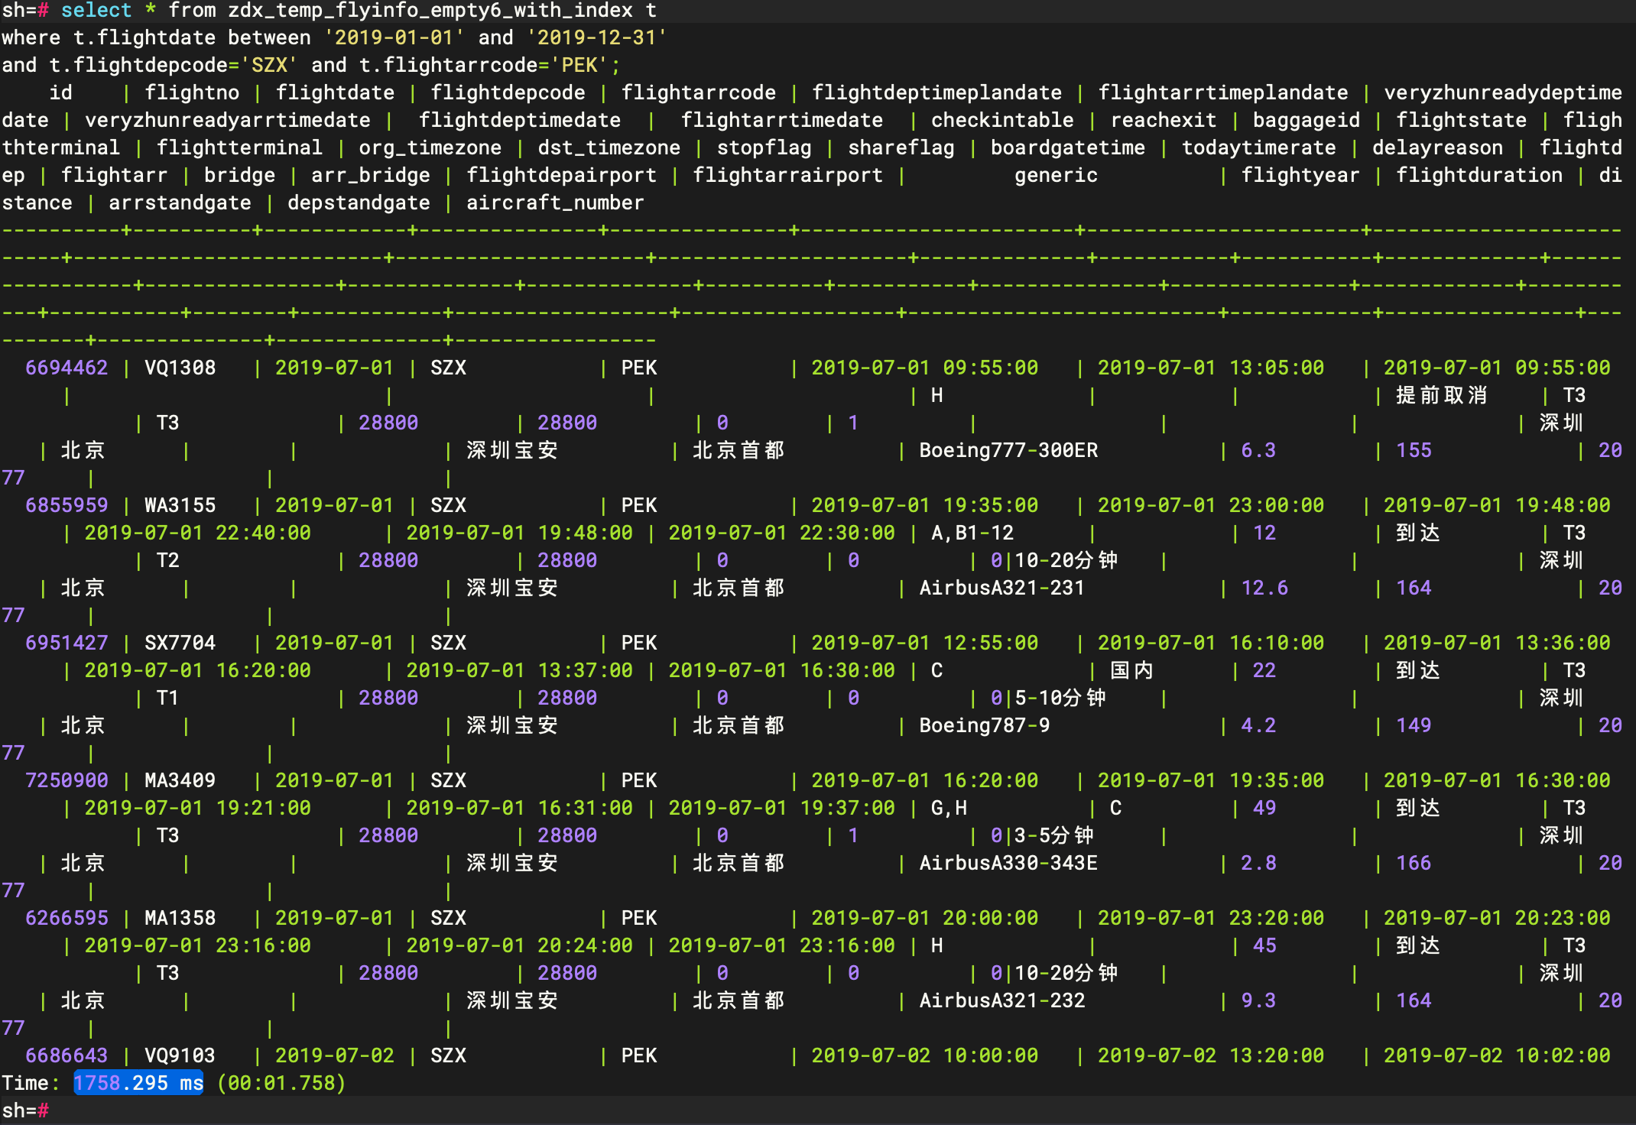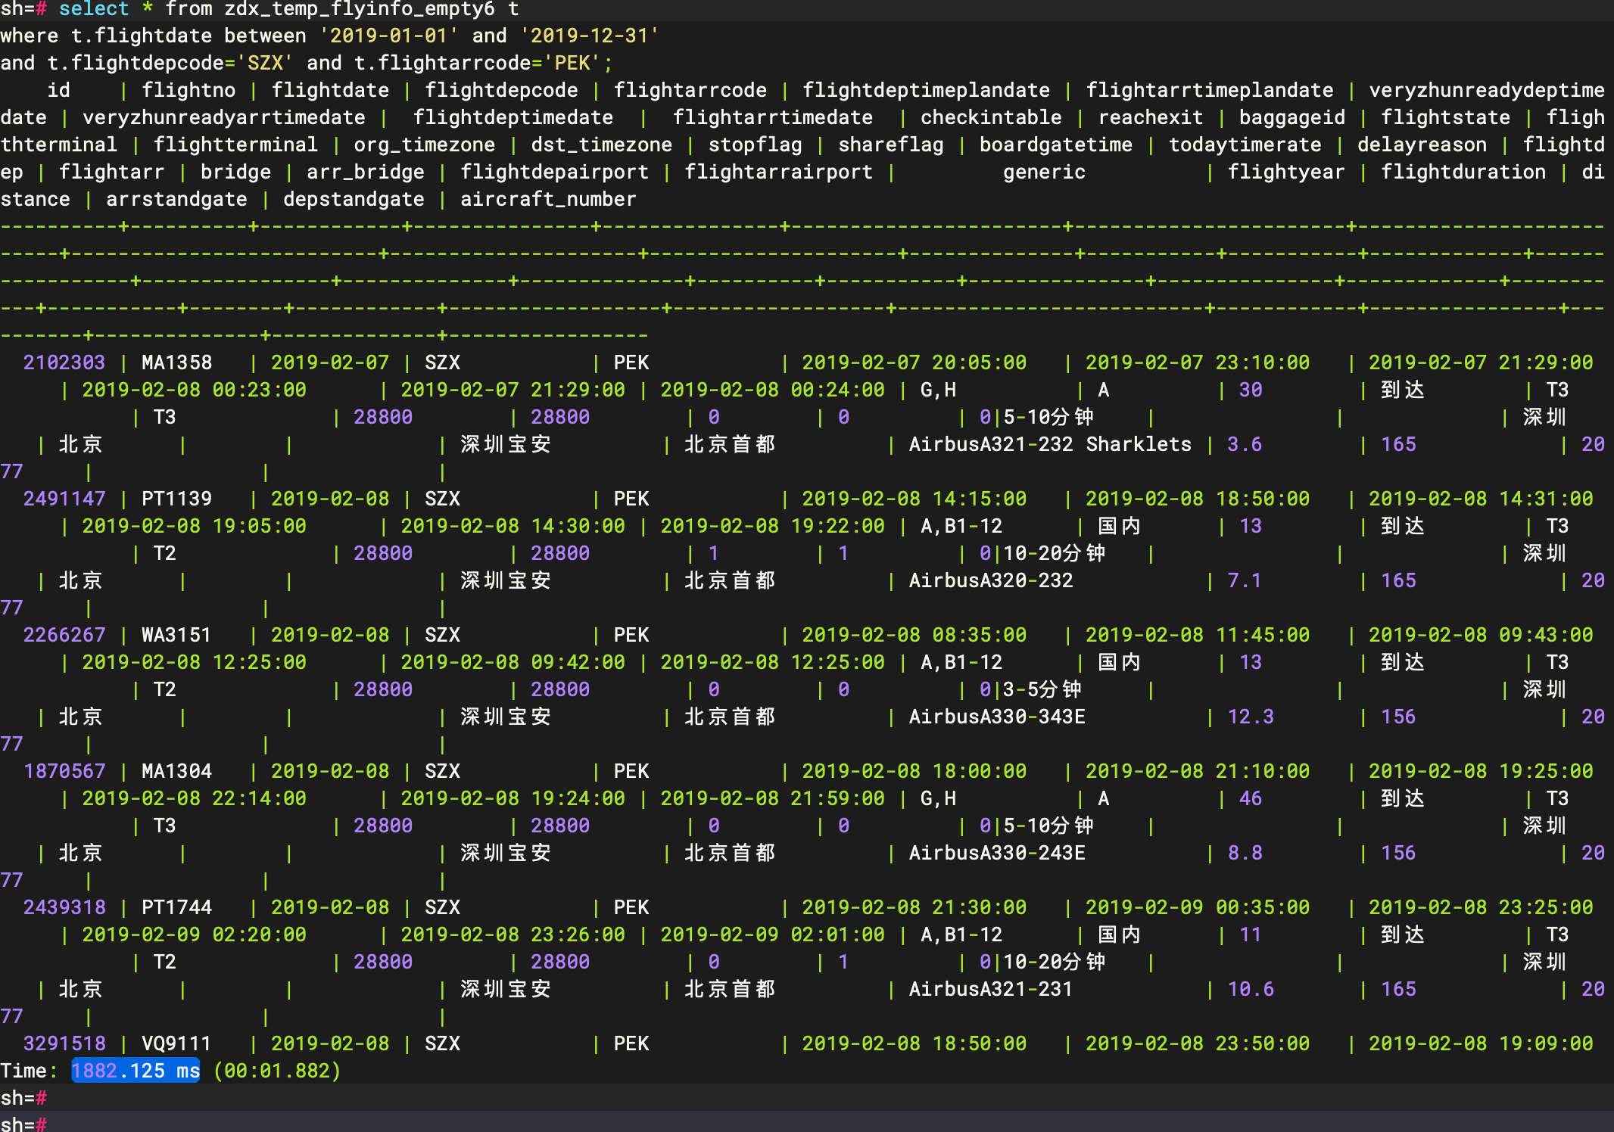

|  |
| --- |
| 数据量108504310 select * from zdx_temp_flyinfo_empty6_with_index t where t.flightdate between '2019-01-01' and '2019-12-31'  and t.flightdepcode='SZX' and t.flightarrcode='PEK'; |

**更新**

在各量级数据表（有索引、无索引），分别执行以下更新语句，记录各自更新时间：

update A27387.zdx_temp_flyinfo t

set t.reachexit='Y'

where t.flightdate between '2019-01-01' and '2019-12-31'

and t.flightdepcode='SZX' and t.flightarrcode='PEK';

|  |  |  |  |  |  |
| --- | --- | --- | --- | --- | --- |
| SQL update zdx_temp_flyinfo_empty6 t set t.reachexit='Y' where t.flightdate between '2019-01-01' and '2019-12-31'  and t.flightdepcode='SZX' and t.flightarrcode='PEK';  update zdx_temp_flyinfo_empty6_with_index t set t.reachexit='Y' where t.flightdate between '2019-01-01' and '2019-12-31'  and t.flightdepcode='SZX' and t.flightarrcode='PEK'; | | | | | |
|  | MARS3 |  | MARS3 idx |  | |
| 数据量1218 | 11.470 ms |  | 15.435 ms |  | |
| 数据量 29454 | 18.392 ms |  | 16.725 ms |  | |
| 数据量441370 | 63.547 ms |  | 18.936 ms |  | |
| 数据量2731118 | 212.408 ms |  | 54.314 ms |  | |
| 数据量10850431 | 642.305 ms |  | 95.338 ms |  | |
| 数据量108504310 | 5445.581 ms |  | 140.660 ms |  | |

**复杂查询**

在亿级表（有索引、无索引）中执行以下语句，记录查询时间

|  |
| --- |
| SQL WITH monthly_data AS (  SELECT  flightdepcode,flightarrcode,  TO_CHAR(flightdate, 'yyyy-MM') AS flightdate_month,  count(1) AS monthly_flight_line,  -- 计算年度总额  SUM(count(1)) OVER (  PARTITION BY flightdepcode,flightarrcode, EXTRACT(YEAR FROM flightdate)  ) AS yearly_flight_line  FROM zdx_temp_flyinfo_with_index  GROUP BY flightdepcode,flightarrcode, TO_CHAR(flightdate, 'yyyy-MM'), EXTRACT(YEAR FROM flightdate) ), ranked_data AS (  SELECT  flightdepcode,flightarrcode,  flightdate_month,  monthly_flight_line,  yearly_flight_line,  -- 计算月度排名  rank() OVER (  PARTITION BY flightdepcode, flightdate_month  ORDER BY monthly_flight_line DESC  ) AS monthly_rank,  -- 计算百分比并保留两位小数  ROUND(monthly_flight_line * 100 / NULLIF(yearly_flight_line, 0), 2) AS percentage  FROM monthly_data  GROUP BY flightdepcode,flightarrcode, flightdate_month, monthly_flight_line, yearly_flight_line ) SELECT  flightdepcode,flightarrcode,  flightdate_month,  monthly_flight_line,  yearly_flight_line,  concat(percentage,'%') AS percentage, -- 添加百分号  monthly_rank FROM ranked_data WHERE monthly_rank <= 3 -- 仅保留前3名 ORDER BY flightdepcode, flightdate_month DESC, monthly_rank; |

|  |  |
| --- | --- |
| MARS3 | MARS3 idx |
| 3083.510 ms | 2912.232 ms |
|  |  |

|  |
| --- |
| SQL select flightdate, flightdepcode || '-' || flightarrcode, count(1) from zdx_temp_flyinfo_empty6 t where t.flightdate between '2019-01-01' and '2019-12-31' and substr(t.flightno,1,2) in ('VQ','MA') group by flightdate, flightdepcode || '-' || flightarrcode order by flightdate; |

|  |  |
| --- | --- |
| MARS3 | MARS3 idx |
| 617.208 ms | 629.076 ms |
|  |  |

**删除**

在各量级数据表（有索引、无索引），分别执行以下删除语句，记录各自删除时间：

delete from A27387.zdx_temp_flyinfo t

where t.flightdate between '2019-01-01' and '2019-12-31'

and t.flightdepcode='SZX' and t.flightarrcode='PEK';

|  |
| --- |
| SQL delete from zdx_temp_flyinfo_empty6 t where t.flightdate between '2019-01-01' and '2019-12-31'  and t.flightdepcode='SZX' and t.flightarrcode='PEK';  delete from zdx_temp_flyinfo_empty6_with_index t where t.flightdate between '2019-01-01' and '2019-12-31'  and t.flightdepcode='SZX' and t.flightarrcode='PEK'; |

|  |  |  |  |  |
| --- | --- | --- | --- | --- |
|  | MARS3 |  | MARS3 idx |  |
| 数据量1218 | 40.899 ms |  | 5.522 ms |  |
| 数据量 29454 | 43.314 ms |  | 13.497 ms |  |
| 数据量441370 | 59.811 ms |  | 16.489 ms |  |
| 数据量2731118 | 82.126 ms |  | 75.186 ms |  |
| 数据量10850431 | 166.157 ms |  | 137.907 ms |  |
| 数据量108504310 | 607.931 ms |  | 540.053 ms |  |